Sharlotte (Dennis) Celestine

September 26, 1952 – June 23, 2019

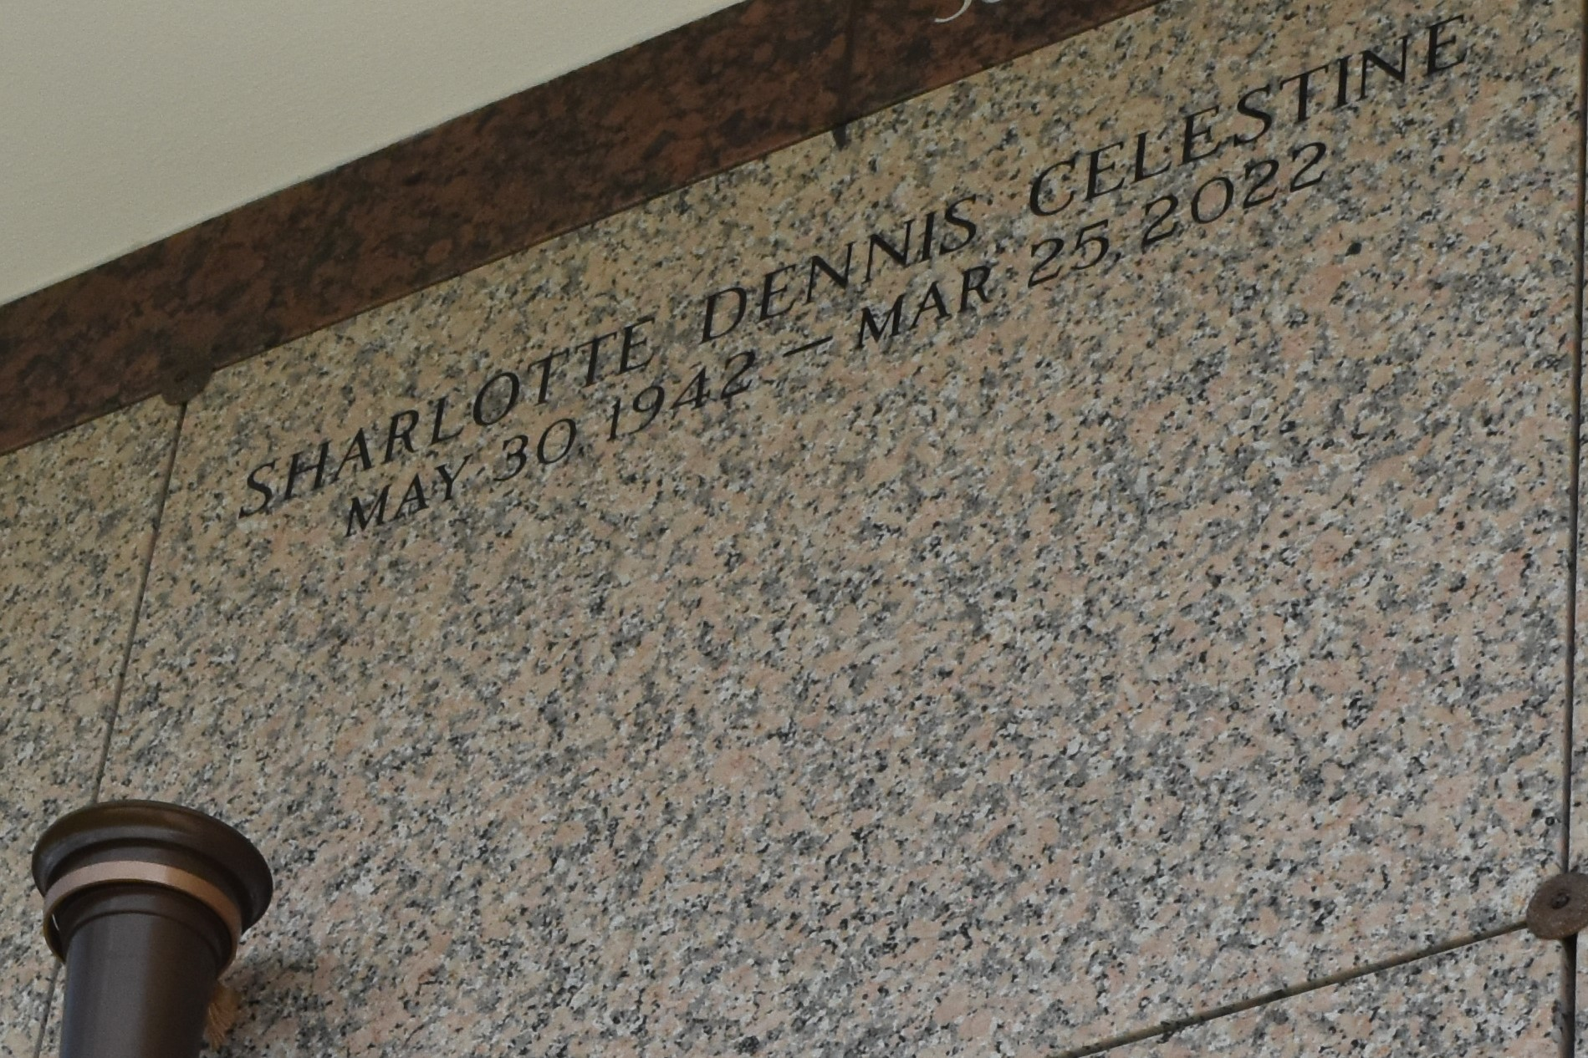

Sharlotte Dennis Celestine departed this life on Friday, March 25, 2022, at the age of 79. Daughter of the late Rev. James Dennis and Shallotte Gant Dennis. Wife of Raymond Celestine. Mother of Betty Dennis, sister of Cora Lee Mitchell, grandmother of Sharonda James and Rodney Dennis. Sharlotte is also survived 8 children she reared as her own children, and a host nieces, nephew, other relatives and friends.

Funeral service will be on Saturday, April 9, 2022 at 11:00 am at Mt. Calvary B.C., 127 W. 3rd St., Laplace, La. 70068. Rev. Freddie Howard Pastor, officiating. Viewing will be held from 9 am until service time. Interment in St. John Memorial LaPlace, La. Due to CDC (COVID-19) restrictions, seating may be limited; mask is required. Professional services entrusted to the caring staff of Hobson Brown Funeral Home, 134 Daisy St., Garyville, La. 70051, 985-535-2516.

The Times-Picayune, New Orleans, Louisiana

from Apr. 7 to Apr. 9, 2022.