Herbert J. Champagne Sr.

April 8, 1943 – June 11, 2014

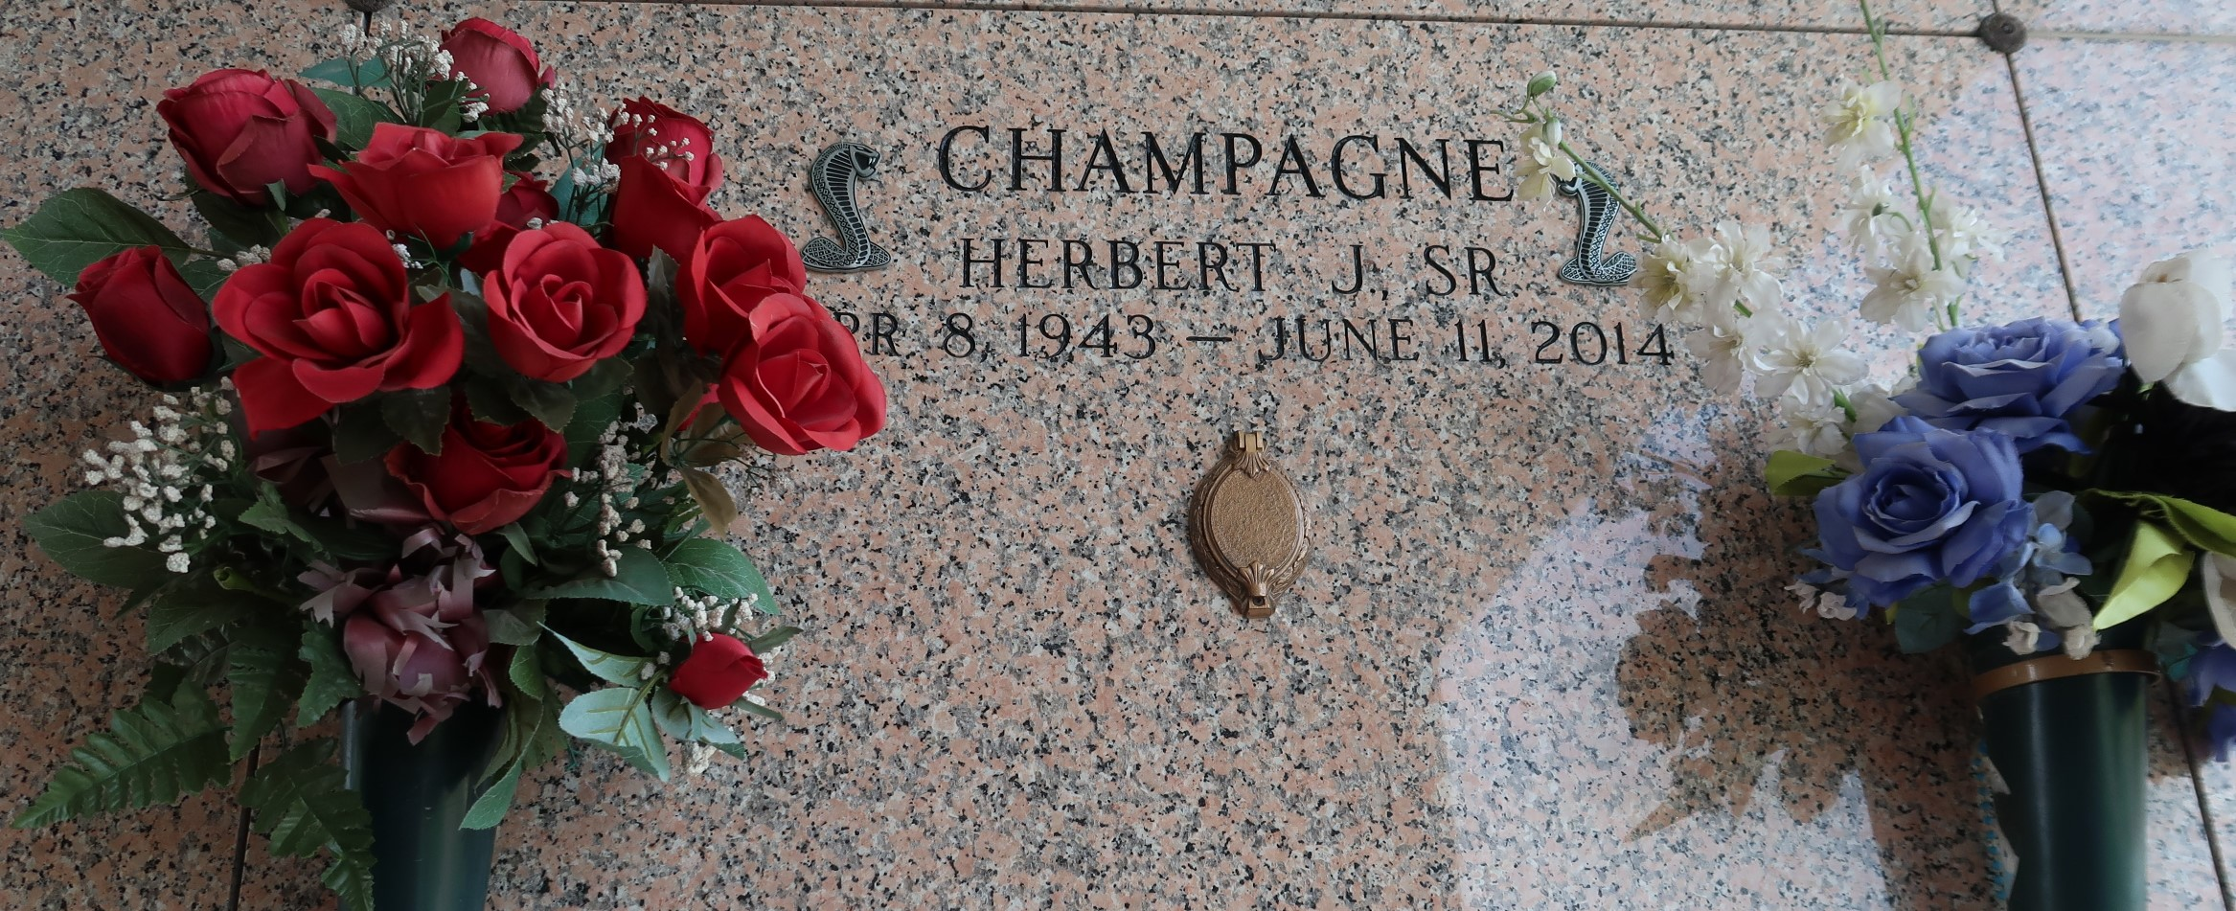

Herbert J. Champagne Sr., died on Wednesday June 11, 2014. Beloved husband of Barbara Duhe Champagne. Father of Melanie C. Poche, Herbert Champagne Jr., Shane Champagne and Michele C. Giordano. Step-father of Ched, Kevin and Ron Edler. 7 grandchildren and 1 great-grandchild. Son of the late Emile and Ernestine Schexnayder Champagne. Brother of John Champagne. Age 71. A native of LaPlace and a resident of Reserve.

Relatives and friends are invited to attend services. Visitation at Millet-Guidry Funeral Home, 2806 W. Airline Hwy., LaPlace, LA on Saturday June 14, 2014 from 8:00am to 10:00am, followed by Religious Services in The Funeral Home Chapel at 10:00am. Burial in St. John Memorial Gardens, LaPlace, LA.

The Times-Picayune, New Orleans, Louisiana

June 12 to June 13, 2014