Dorothy (Hotard) Chauvin

November 4, 1922 – August 16, 2013

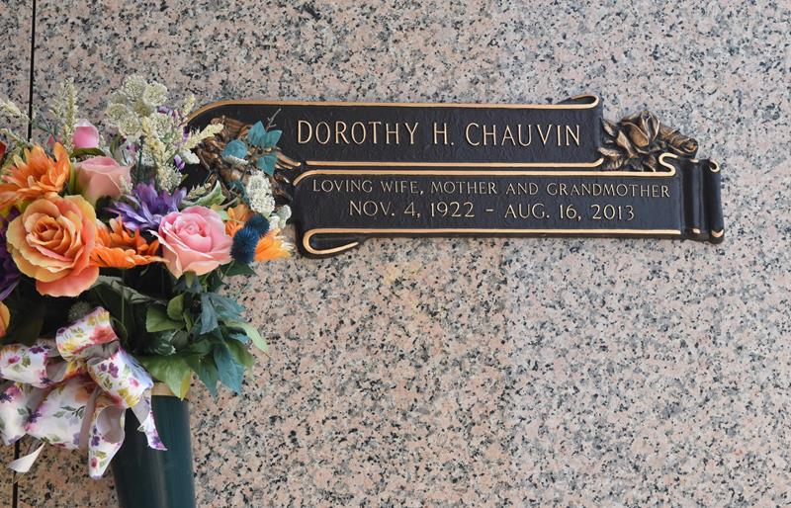

Dorothy H. Chauvin passed away on August 16, 2013. She is the mother of Barbara Dugas (John), Susan Lambremont (Jay), E.J. Chauvin Jr. (Lisa), and the late Shirley Waguespack (Lynn). Grandmother to Connie, Carol, Libby, Linette, Trisha, Trey, Tara, Lisa, Stephanie, Jay, Crystal and Samuel. Great grandmother to Kaci, Brittany, Jeremy, Jade, Jessica, Brandon, Dillon, Taylor, Maggie, Austin, Alex, Addison, Lainnie, Lauren, Landyn, Emma, Ella, Easton, Jared, Jordan, Jaxson, Noah, Noelle and Olivia. Great-great grandmother to Bella. Sister to Warren Hotard. She is preceded in death by her husband Elmore Chauvin and 5 brothers and sisters.

Relatives and friends are invited to attend a visitation at Sacred Heart of Jesus Catholic Church in Norco, LA on Wednesday August 21, 2013. Visitation will begin at 9:30AM until 11:00AM. A funeral Mass will be held at 11AM. Interment will follow at St. John Memorial Gardens. Condolences may be expressed at [www.hcalexanderfuneralhome.com](http://www.hcalexanderfuneralhome.com/)

The Times-Picayune, New Orleans, Louisiana

August 16 to August 18, 2013