Elmore Joseph Chauvin Sr.

November 29, 1917 – October 12, 1979

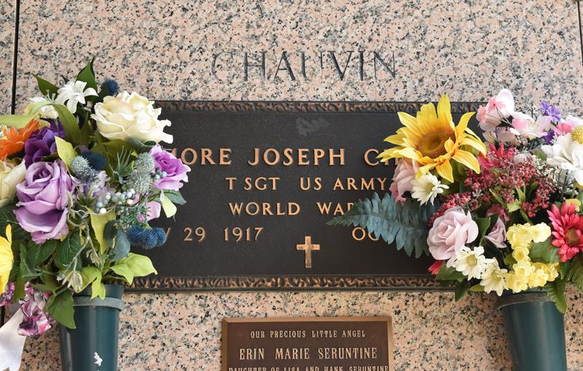

Elmore J. Chauvin, Sr., on Friday, October 12, 1979 at 4:15 p.m., husband of Dorothy Hotard Chauvin, son of the late S. P. Chauvin, Sr. and Edna Guidry, father of Mrs. Mrs. Shirley Waguespack, Mrs. Barbara Dugas, Mrs. Susan Lambremont and E. J. Chauvin, Jr., brother of Mrs. Maude Hymel, Sidney, Curtis and Harry Chauvin, also survived by 10 grandchildren, age 61 years, a native of Garyville, La. and a resident of Laplace for the past 31 years.

Relatives and friends of the family also employees of G.A.T.X. and the Bank of St. John are invited to attend the funeral. Services from the H. C. Alexander Funeral Home, 821 4th street, Norco, on Monday, October 15, 1979 at 11:00 a.m. Religious services at St. John of Arc Catholic Church, Laplace, LA. Interment in St. John Memorial Gardens, Laplace, LA. Friends may call from 4:00 until 11:00 p.m. on Sunday, October 14, 1979.

The Times-Picayune, New Orleans, Louisiana

Sunday, October 14, 1979