Anna Lee (Howard) Childress

June 27, 1927 – October 30, 2003

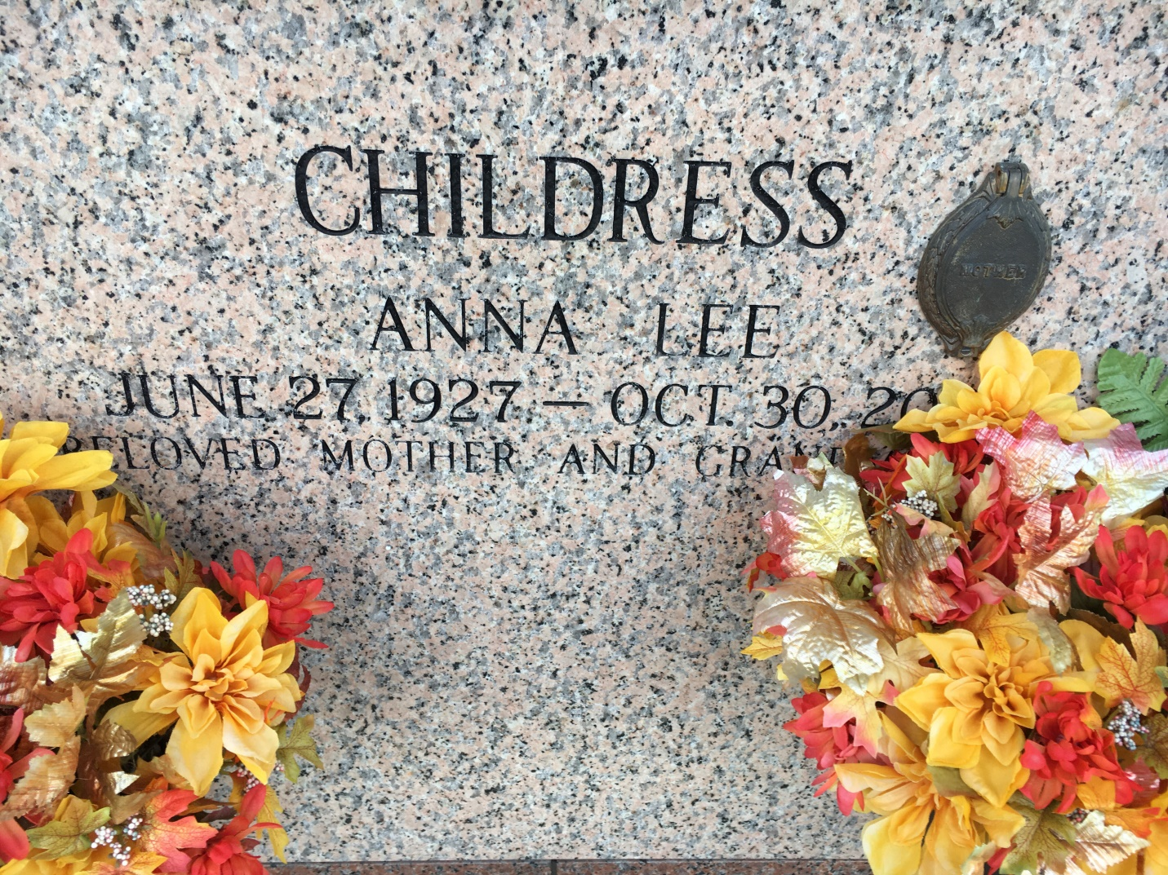

Photo by Team T Lo

Anna Lee Howard Childress On Thursday, October 30, 2003 At 7am In Slidell. Daughter Of The Late Charlie Pete And Annie Johns Howard. Mother Of Henry 'Lavell' And Sharon Childress, Laplace, Nolan And Paula Childress, Ponchatoula, Judy And Glen Woods, Pearl River. Sister Of Frances Drummond, Rayville, The Late Dude Howard. Also Survived By 10 Grandchildren, 23 Great Grandchildren. Age 76 Years. A Native Of Rayville And A Resident Of Slidell. Graveside Service At 4pm At St. John Memorial Gardens In Laplace On Sunday, November 2, 2003. Visitation At Alexander Funeral Home, Lutcher From 4pm To 9pm On Saturday. Alexander Funeral Home-Lutcher In Charge

Times Picayune (LA); 11-01-2003