Samuel Clay Jr.

Jun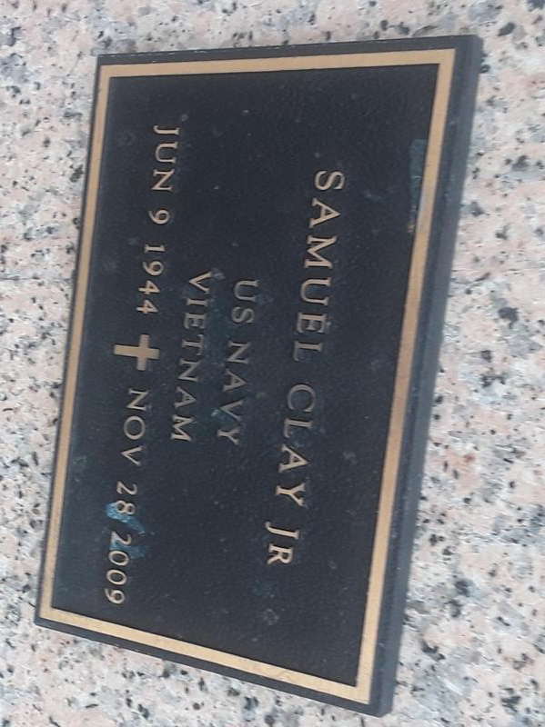e 9, 1944 – November 28, 2009

Coach Samuel Clay, Jr. passed away on Saturday, November 28, 2009, at age 65. A native of Houston, TX, and resident of LaPlace, La. Son of the late Samuel and Annie Mae (Gross) Clay. Husband of Velma Jacob Clay. Father of Benjamin (Annette) Clay, and the late Patrick Clay. Brother of Nathan (Louella Clay) III. Stepfather of Isaac (Trishele) Stewart, Jr. and Angela Stewart. Also survived by a host of grandchildren, and a host of brothers- and sisters-in-law, nieces, nephews, other relatives and friends.

Samuel Clay, Jr., was a Vietnam War Veteran U.S. Navy and he received a Vietnam Service Medal with 1 Silver Star and National Defense Service Medal.

Relatives and friends of the family, pastors, officers and members of Mt. Calvary B.C. and all neighboring churches, Southeast Louisiana Veterans Health Care System, VFW Post 3337, American Legion 395, River Region Hospice and United States Postal Service New Orleans Branch are invited to the Funeral Service on Saturday, December 5, 2009 from the above named church, 127 W. 3rd., LaPlace, La. at 10:30a.m. Rev. Dr. Freddie Howard., Pastor - Officiating. Burial in St. John Memorial Cemetery, LaPlace, La. Viewing at the Church on Saturday from 9:00a.m. until service time. Service Entrusted to Hobson Brown Funeral Home, Garyville, La., (985) 535-2516.

The Times-Picayune, New Orleans, Louisiana

Friday, December 4, 2009

Contributed by Jane Edson