Alvin Jude Clement

March 11, 1938 – July 18, 2022

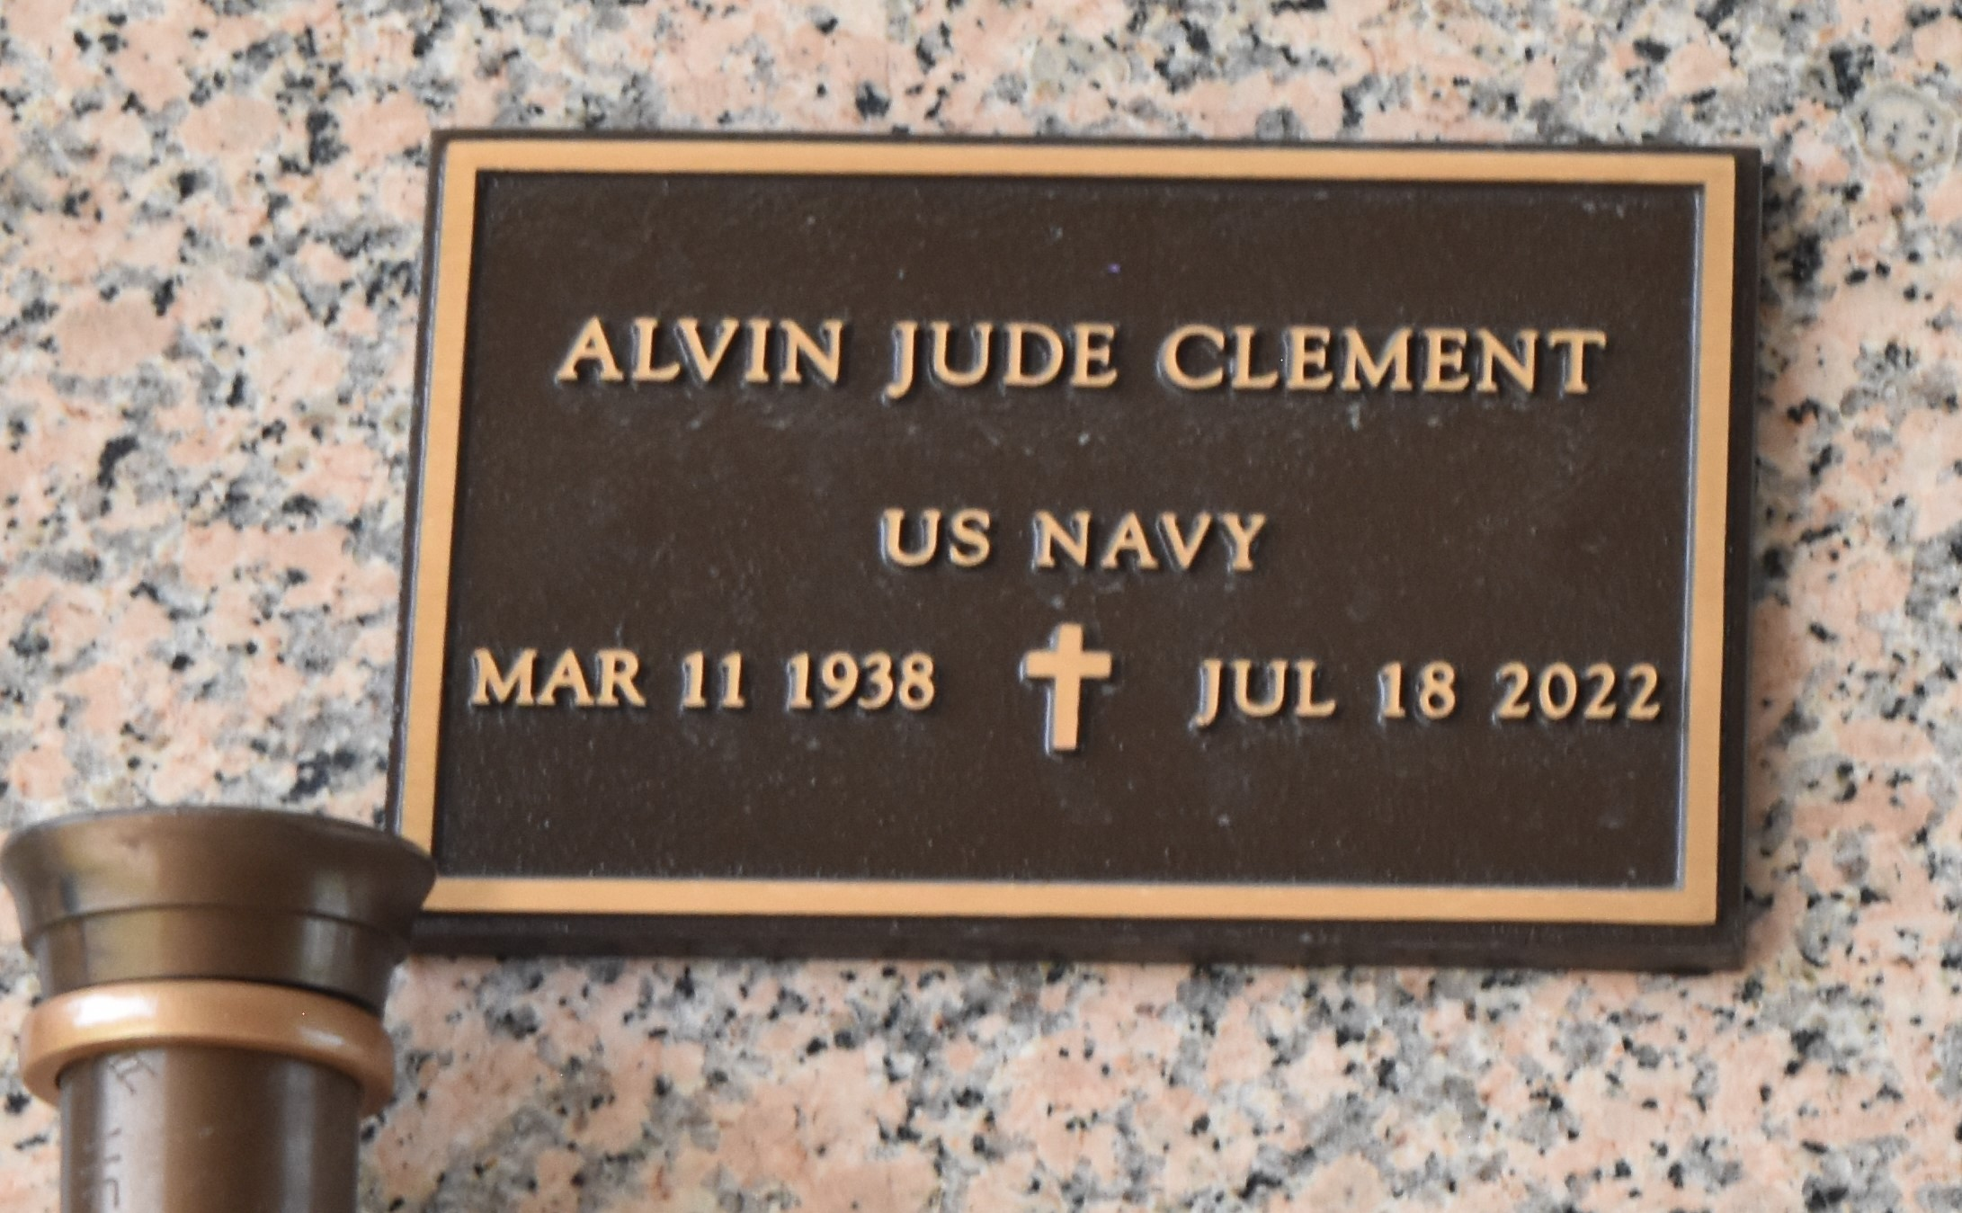

**Alvin Jude Clement**peacefully passed away on Monday, July 18, 2022, at the age of 84. He was the son of the late Joseph and Rosa Millet Clement. Husband of Carole Flowers Clement. The proud father of Durban M. Clement, Lori (Michael) Flowers and the late Sheryl Flowers.

Loving brother of the Donald Ray Clement, Joyce (the late Leroy) Houston,Willie (Anita) Clement, Rose Mary Pidgeon and the late Harrriet (Matthew) Banks, Joseph (Lucinda) Clement, Jr., Margaret (Anderson) Perrilloux, Lois (Norwood, Sr.) Clark, Doris (Herman) Jones.  He is also survived by 19 nieces and nephews as well as other relatives and friends.

Alvin grew up in LaPlace, Louisiana. After graduating from Fifth Ward High School, he enlisted in the U.S. Navy where he served for four years in Philadelphia, Pennsylvania and San Diego, California. Alvin then attended Southern A&M University where he earned a Bachelor of Arts degree, majoring in Accounting.

After college, Alvin worked for Honeywell in Minneapolis, Minnesota prior to an accomplished 25-year career with Xerox where he worked in Rochester, New York and Freemont, California.

The family would like to thank everyone that cared for Alvin at the Southeast Louisiana Veterans Home during the past few years. We are grateful for your dedication to his health and comfort.

Relatives, friends of the family, Priest and Parishioners of Our Lady of Grace Catholic Church are invited to a Mass of Christian Burial on Friday, July 29, 2022, 11:00 am at Our Lady of Grace Catholic Church. 780 Hwy44, Reserve, LA. 70084. Fr. Godwin Ani, SSJ-Celebrant. In accordance with the CDC guidelines for COVID-19 mask are suggested. Visitation 9:00 am until time of Mass at the above-named church. Private Interment. There will also be a Walk-thru visitation on Thursday, July 28, 2022 from 5:00 pm to 7:00 pm at the Patrick H. Sanders Funeral Home. Final Arrangements are entrusted to Patrick H. Sanders Funeral Home & Funeral Directors, Inc. 605 Main Street, LaPlace, LA 70068. For Information please call (985) 359-1919.

Patrick Sanders Funeral Home, LaPlace, Louisiana