Guy L. Clement

July 3, 1935 – July 26, 2020

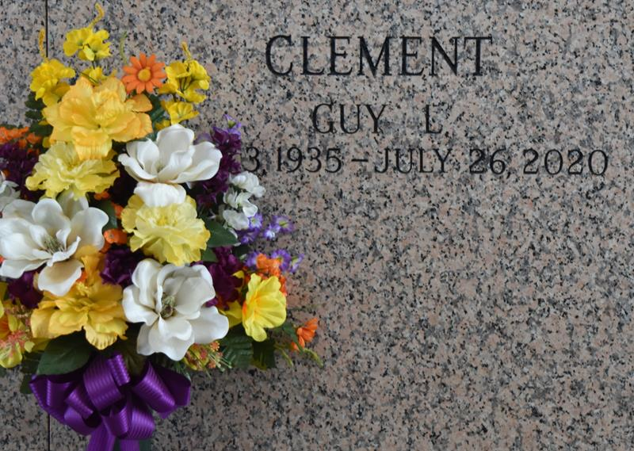

Guy L. Clement passed away at his residence surrounded by family on Sunday, July 26, 2020 at the age of 85. He was a native and lifelong resident of LaPlace, LA. Guy retired from Shell Chemical after 35 years of service. Guy embodied what it meant to be from south Louisiana. An avid duck and deer hunter with his sons, to crabbing at his camp on the backs of Lake Maurepas with his high school sweetheart and wife Patty, riding in the parades of LaPlace and New Orleans, and beaching it with his family on the shores of Alabama. Guy was bigger than life, never meeting a stranger and always there if anyone needed help or a great cooked meal. His heart was as big as his love for his family and friends. The south was a better place with him in it, but his legacy will continue on with all those that he touched, for anyone that met him was left with a joy for living life to its fullest.

Beloved husband of 65 years to Patty Klibert Clement. Loving father of Kirt Clement (Patti), Jennie C. Smith (Bryan), Wade Clement (Jeanette), Marcelle Clement and Dyanne Clement. Grandfather of Christopher Clement (Leanne), Elizabeth Clement, Jacques Clement, Justin Smith, Connor Smith, Joshua Harris (Krista) and Jesse Harris. Great grandfather of Lorelei and Evie Clement and Lila and Jacob Harris. Son of the late Emile M. Clement and Marcelle Millet Clement. Brother of Roland Clement (Gayle) and the late Vernon Clement (Mabel) and Claude Clement. Also survived by nieces and nephews.

The family would like to give a special thanks to his care givers, Tracy Smith and April Accomando.

Relatives and friends are invited to attend the Funeral Mass at St. Joan of Arc Catholic Church, 529 W. 5th Street, LaPlace on Thursday, July 30, 2020 at 12:00 p.m. Visitation from 10:00 a.m. until 12:00 p.m. Interment in St. John Memorial Gardens Cemetery. In lieu of flowers, Masses preferred.

Millet-Guidry Funeral Home, LaPlace, Louisiana

July 28, 2020