Thelma Marie (Cortez) Clement

February 23, 1926 - July 28, 2019

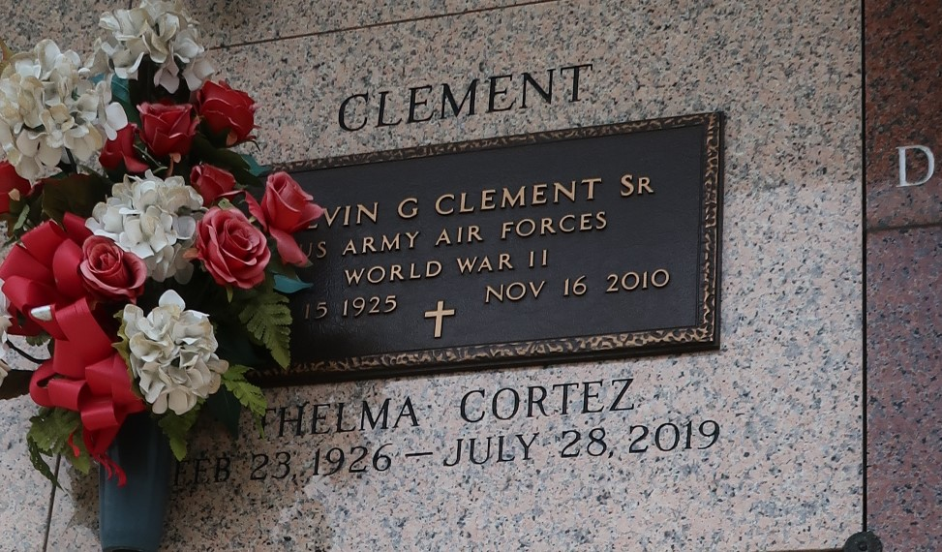

Thelma Marie Cortez Clement passed away surrounded by her family on Sunday, July 28, 2019 at the age of 93.   
 Beloved wife of the late Calvin G. Clement, Sr. Loving mother of C. J. Clement (Rosalind), Nancy Clement LeBlanc (Keith), Brenda Clement Callahan (James), and Bonnie Bumgarner Voelkel (Larry). Daughter of the late Edward Joseph and Grace Louquette Cortez. Sister of Jeanette Thompson and the late Butsy Cortez, Ernest Cortez, Richard Cortez, Pete Cortez, Toby Cortez and Doris Pitre. Also survived by 10 grandchildren, 17 great grandchildren, nieces and nephews.  
 Relatives and friends are invited to attend the Funeral Mass at Ascension of Our Lord Catholic Church, 799 Fairway Dr., LaPlace on Wednesday, July 31, 2019 at 11:00 a.m. Visitation will begin in church at 9:30 a.m. Interment in St. John Memorial Gardens Cemetery.

Millet-Guidry Funeral Home, LaPlace, Louisiana

July 30, 2019