Milton Clofer

November 17, 1964 – June 11, 2014

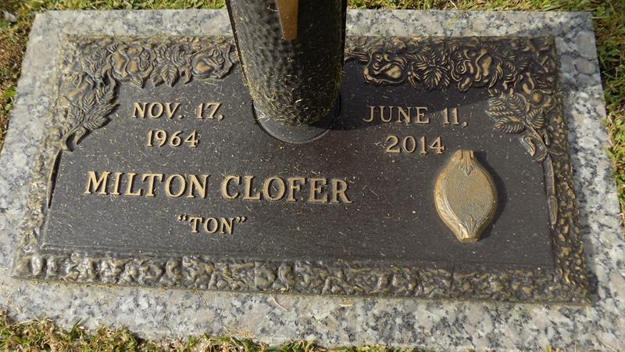

Milton 'Ton' Clofer Jr passed away on Wednesday, June 11, 2014. Son of Juanita (George) Cloudet and Milton Clofer Sr., he leaves to cherish her memory 6 daughters, 1son, 4 sister, 3 brothers, nieces, nephews, other relatives and friends.

Services will be held on Saturday June 21, 2014 at 11:00am at Mt. Calvary B. C., 127 W 3rd St. Laplace, LA. Viewing from 9:00am until service time. Internment at St. John Memorial, Laplace, La. Service Entrusted to Hobson Brown Funeral Home, Garyville, La 70051; 985-535-2516.

Times-Picayune, The (New Orleans, LA)

Friday, June 20, 2014  
Contributed by Jane Edson