Robert E Cochran II

December 17, 1972 – April 6, 2006

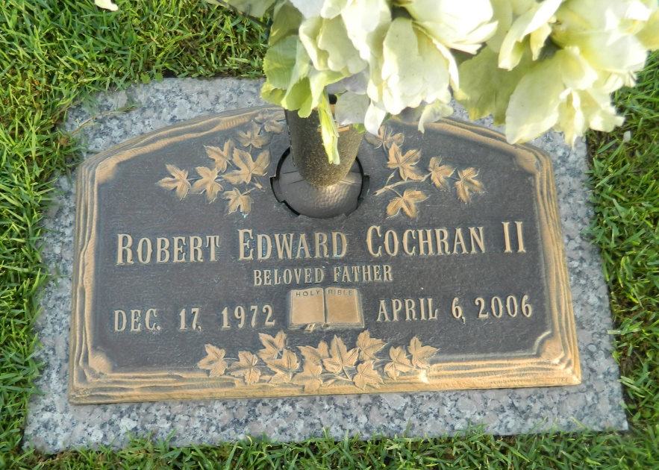

Photo by Margie Pearce

Robert E. Cochran II on Thursday April 6, 2006 at 11:33 p.m. Beloved husband of Sabrina Cochran. Father of Robert Cochran III, Megan and Karen Cochran. Son of Linda Cochran and the late Robert Cochran. Brother of Bobbie Bailey, Kristal Cochran and Amber Causey. Age 33. A native of Metairie and a resident of New Orleans.  
  
Relatives and friends of the family are invited to attend services. Visitation at Millet-Guidry Funeral Home, 2806 W. Airline Hwy, Laplace on Wednesday April 12, 2006 from 10:30am until 1:30 pm. Followed by religious services at the funeral home chapel at 1:30 p.m. Burial in St. John Memorial Garden Cemetery, Laplace.

Times-Picayune, The (New Orleans, LA)

Tuesday, April 11, 2006

Contributed by Jane Edson