Gladys Collins

January 22, 1936 – August 15, 2013

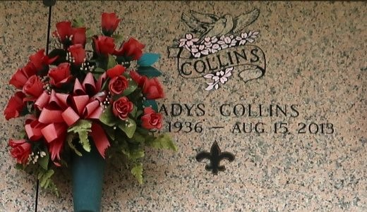

Gladys Collins entered into eternal rest on Thursday, August 15, 2013 at the age of 77 years old. Daughter of the late Florence and Son Collins, Sr. Devoted friend of Paul Oubre. Mother of Annette (Dennis) Jones of Dallas, Texas. Grandmother of Rochelle Askin, Tyuana Miles, and Deunca Dyas of Dallas, Texas. Sister of Mary Collins Brooks and Gwendolyn Collins Eaglin of Houston, Texas, Son Collins, Jr., Melvin Collins of Shewbury, MA, Glenn Collins, Sr., and the late Ramona Morgan, Alice Maynard, Raymond Collins and Felton Collins, Sr. Her niece reared as her sister Rowena Morgan Brown. Also survived by a host of great grandchildren, nieces, nephew, cousins, other relatives and friends.

Funeral services will be held at The New Pilgrim Baptist Church, 129 Pilgrim Drive, Reserve, La., on Saturday, August 24, 2013 at 1:00 p.m. Visitation will be from 11:00 a.m. until time of service. Pastor Forell Bering, Sr. will be officiating. Interment will be at St. John Memorial Gardens Cemetery, Laplace, La. Funeral entrusted to The Baloney Funeral Home, LLC, 1905 W. Airline Highway, Laplace, La., 985-224-8460. Condolences can be expressed at [www.baloneyfuneralhome.com](http://www.baloneyfuneralhome.com/).

The Times-Picayune, New Orleans, Louisiana

Aug. 21 to Aug. 23, 2013