Maurice Lawrence Cortez Sr.

## April 12, 1946 – October 2, 2004

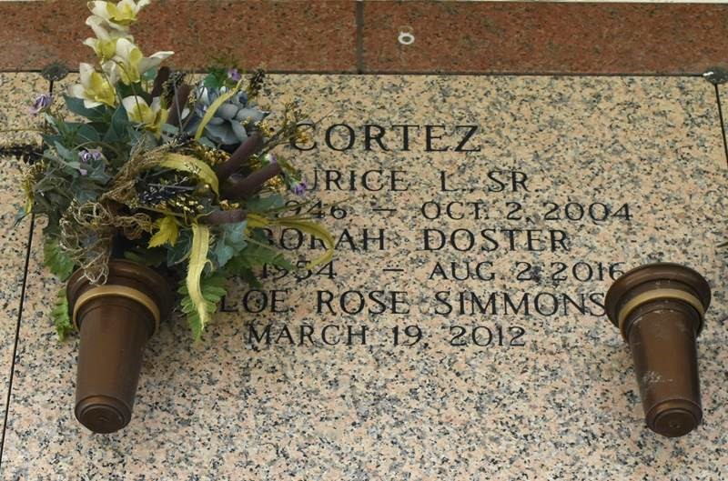

LAPLACE - Maurice Lawrence Cortez, 58, a native of St. Charles Parish and resident of Nashville, Tenn., died Oct. 2. He was the husband of Deborah Duster (sic-Doster) Cortez and father of Debbie Culbertson, Peggy Thibodeaux, Tammy Bogart, Lisa, Anthony and Maurice Cortez Jr. He was also the son of the late Freddie and Louvina Rome Cortez, and brother of Vernice Blanks, Mary Chadwick, Calvin, Clarence, Richard and Joe Cortez. He is also survived by seven grandchildren.

Services were Oct. 7 in the chapel of Millet-Guidry Funeral Home, LaPlace, with interment at St. John Memorial Gardens, LaPlace.

L'Observateur, LaPlace, Louisiana

Thursday, October 14, 2004