Durell Daigre Sr.

April 3, 1968 – August 3, 2018

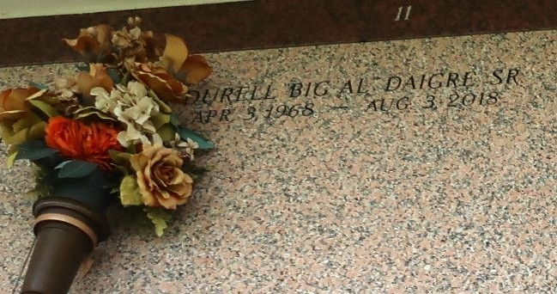

Durell "Big Al" Daigre Sr, age 50, departed this life on Friday, August 03, 2018. Son of the late Aldonia and Johnny Daigre, Sr., father of Durell (Tiger) Daigre Jr. and step daughter Danielle Taylor of whom her reared. Brother of Johnny Jr., Bryant Sr., Ronnie Daigre, Andrea Anderson and Glenda Duperclay. Durell is survived by a very devoted friend Laverne Taylor, 2 other step daughters, and a host of nieces, nephews, other relatives, friends.

Celebration service will be held on Saturday August 11, 2018 at True Light B.C. 258 S. Little Hope St., Garyville, La 70051 at 11:00 am. Rev. Wesley Anderson Pastor, Rev. Kevin Fredericks Officiating. Viewing will be at the above name church on Saturday from 9:00 am. Until Service Time. Internment St. John Memorial Gardens. Professional Services entrusted to the caring staff of Hobson Brown Funeral Home, 134 Daisy St., Garyville, La 70051, (985) 535-2516.

Published in TheNewOrleansAdvocate.com from Aug. 9 to Aug. 11, 2018