Richard J. Daley III

March 20, 1947 – November 17, 2016

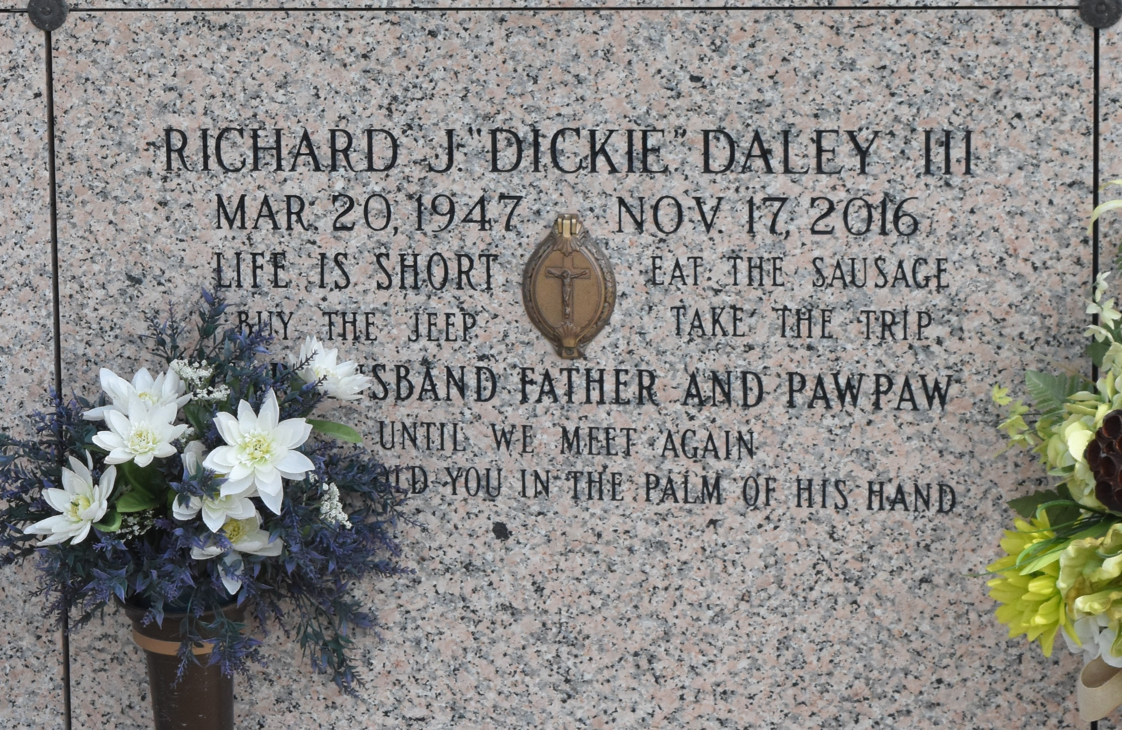

Richard J. 'Dickie' Daley III passed away on Thursday, Nov. 17, 2016. He was 69, a native of Bay St. Louis, Miss., and a resident of LaPlace. He was the beloved husband of Marsha Vicknair Daley; father of Chris Daley, Troy Daley and the late Richard J. Daley IV and Kim Daley Levatino; son of the late Naomi Santen Daley and Richard J. Daley; brother of Kathy Rhoades, Donna White, Jan Labon, Rene Butler and Karen Labon; grandfather of Jake Levatino, Layla Daley, Miley Daley, Chloe Bleakley and Cami Bleakley; father-in-law of Shelley Daley and Matt Levatino and nephew of Robert Santen. Dickie was preceded in death by his very special aunt, Nellie D. Martin, and will be sadly missed by his cousins, nieces, nephews, brother-in-laws, sister-in-laws, many good friends and his work family. Relatives and friends are invited to attend the Memorial Mass at St. Joan of Arc Catholic Church, 529 W. 5th St. in LaPlace on Tuesday, Nov. 22 at 11:30 a.m. Visitation at the church is from 9:30 until 11:30 a.m. Inurnment is in St. John Memorial Gardens Cemetery. To view or sign the online guest book, please visit milletguidry.com.

L'Observateur (LaPlace, Louisiana)

Saturday, November 19, 2016