Christina Marie (Green) Davis

July 14, 1948 – October 11, 2020

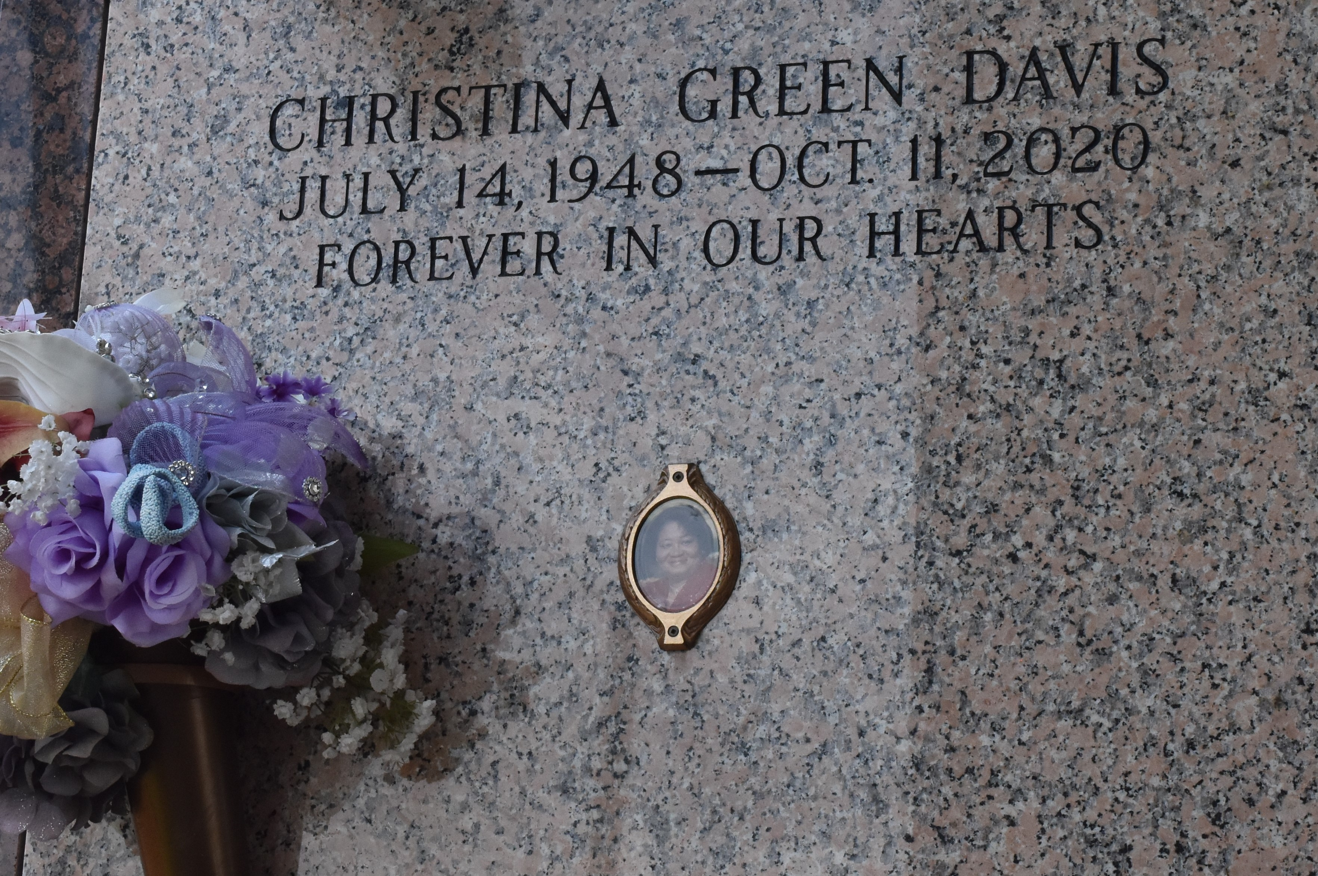

Christina Marie Green Davis departed this life on Sunday, October 11, 2020, at her residence. She was born in Brooklyn, New York on July 14, 1948 to the union of Lillie Mae Ricard and Benjamin Thomas Green Sr. On July 13, 1968, she married Ernest Richard Davis. God blessed their union with one daughter, Adrian Ann Davis Walker. Christina and her parents returned to Garyville, LA where she was reared with her sisters and brothers.  
 Christina accepted Jesus Christ as her personal Lord and Savior, at the age of 11. She was baptized by the late Rev. Paul Roussell at True Light Baptist Church. Ironically, she entered eternal life on the same day she was baptized 61 years ago.  
 In August of 1965, with the support of her parents, Christina decided to attend Leon Godchaux High. She became the first black student to attend an all-white school. She graduated as Salutatorian of her class in May of 1966. After graduating high school, she went to Brooklyn College.  
 Christina returned to Reserve, where she became employed by the Veterans Administration Office in New Orleans. After 30 years of employment, she retired on January 3rd, 1998.  
 Following her husband’s footsteps, Christina became a member of Plymouth Rock Baptist church in November 1978. She worked in the office with Leroy D. Williams and continued to serve until the time her death.  
 Christina leaves to cherish her precious memories a devoted daughter Adrian Ann Davis Walker; four grandchildren Dontrielle' Keondre' Davis, Christiana (Lydell) Marie Walker Julien, Allicyn (Justin) Rayann Walker Miller and Donald Ray Walker, Jr.; twelve great grandchildren Aiana J'Nae, Davon Keith, Travon DeOndre', Justin John, Lydell Anthony, Tavin DeOntae', Maddicyn Mariah, Christian Richard, Aleeah Raylynn, Landon Adrian, Logan Aiden, A'Lyonni J'Nai; two sisters Conchetta Mason and Sandra Snyder both of Dallas, TX; two brothers Benjamin T Green, Jr. of Tacoma, WA and Michael (Valencia) J. Green, Sr. of Reserve, LA; one Godchild Javis (Aristine) McKarry of Reserve, LA; devoted friends Myrtle Lennix, Brenda Washington, Anthony Brown and John Green and a host of other relatives and friends.  
 She was preceded in death by her husband Ernest Richard Davis, parents Lillie and Benjamin Green, Sr., son-in-law Donald Walker, Sr., mother-in-law Lillie West Davis, sister-in-law Ellis Mae Perrilloux, Godparents Wilbert and Frances Winfield, one niece Candace Nichelle Green and one nephew Clifton Duhe.  
 Relatives and friends are invited to attend a celebration of life on Friday, October 16, 2020 at New Wine Christian Fellowship, 1929 W Airline Hwy, LaPlace, LA 70068. Viewing will begin at 2pm followed by a service at 3pm. Entombment to follow at St. John Memorial Gardens, LaPlace, LA. Final care entrusted to Treasures of Life Funeral Services, 315 E. Airline Hwy., Gramercy, La. 70052.

Treasures of Life Funeral Services, Gramercy, Louisiana