Damonisha Kearon Davis

November 1, 2002 – June 4, 2022

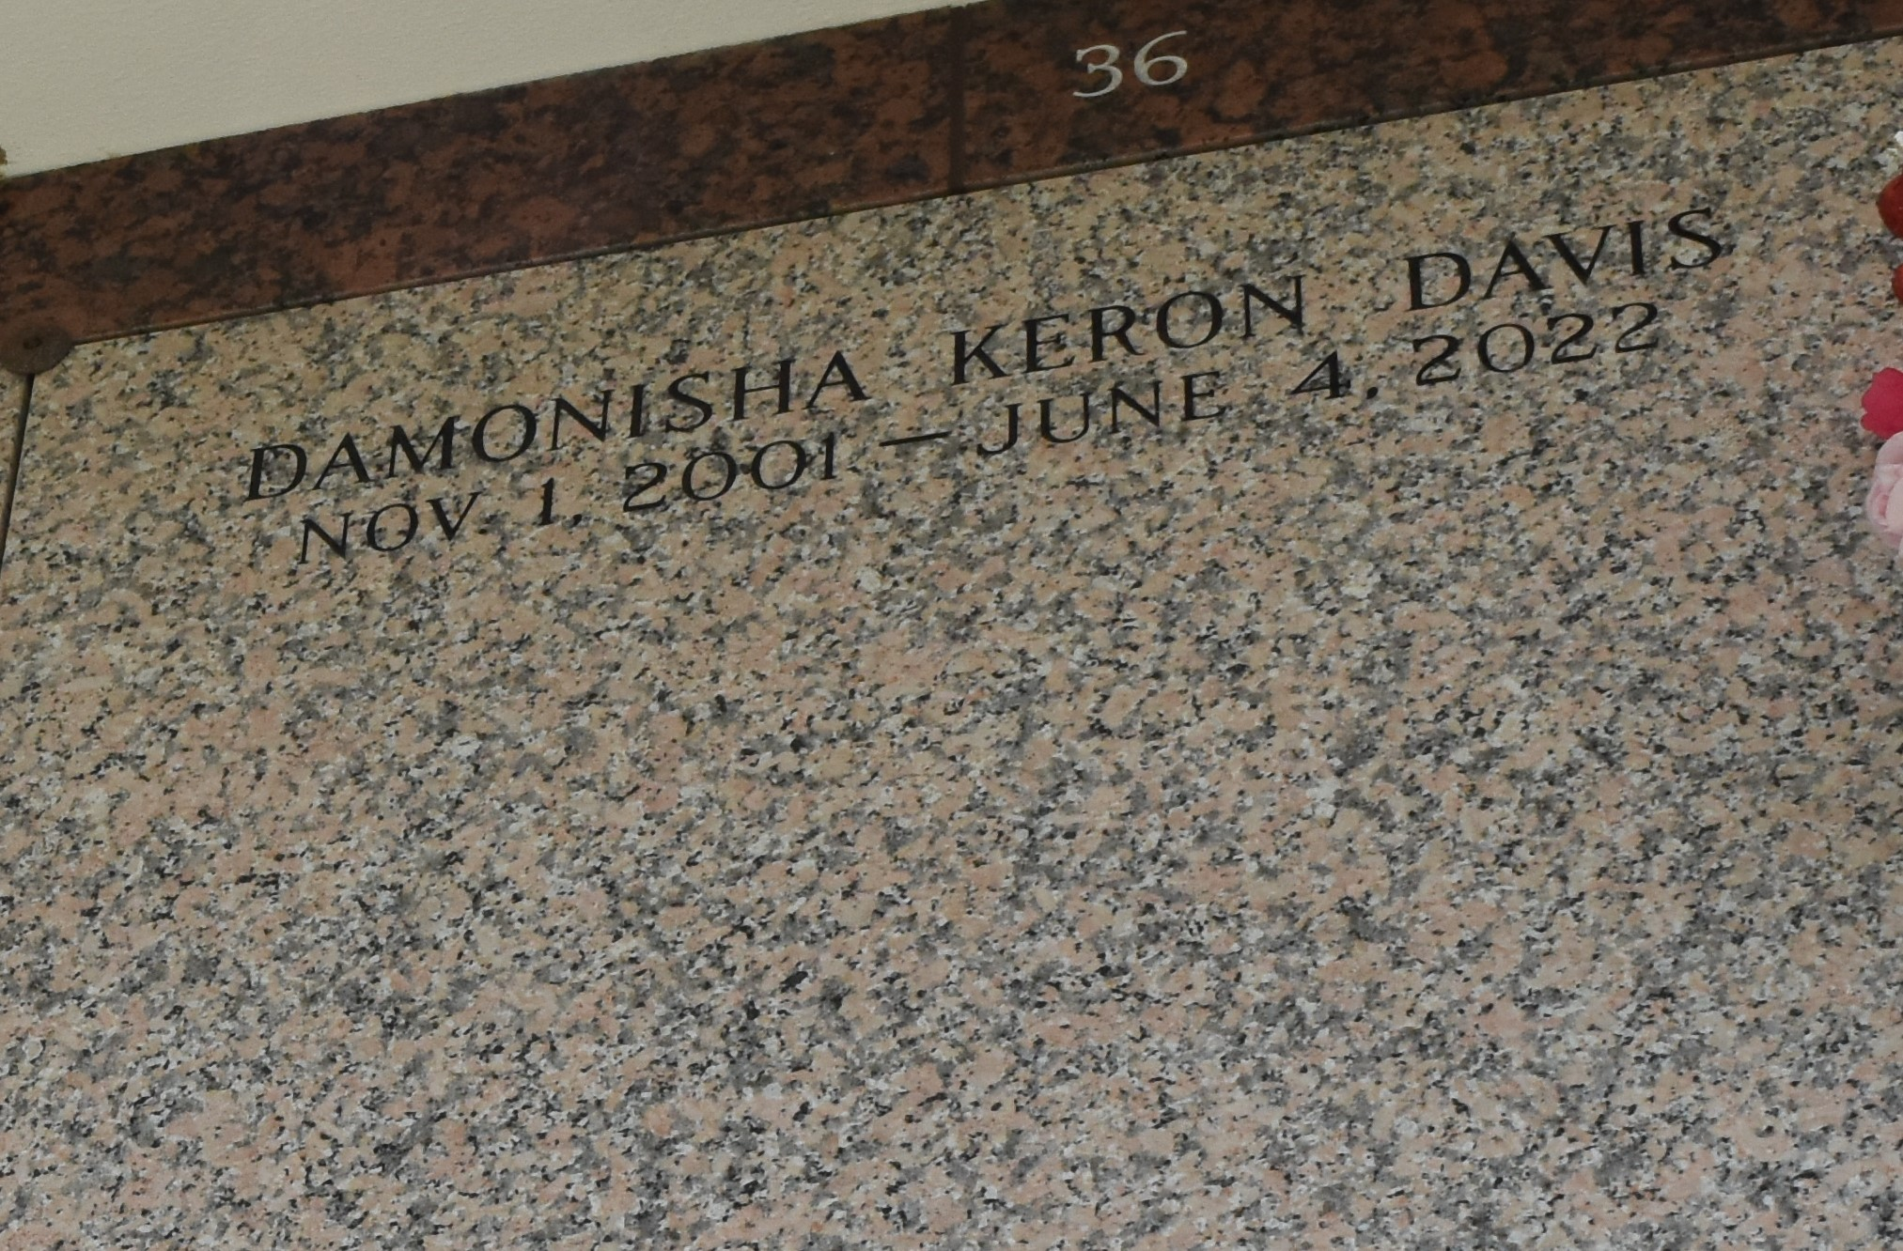

Damonisha Kearon Davis, affectionately known as “Nus”, departed this earthly life on Saturday, June 4, 2022, at the age of 20. She was a native and resident of LaPlace, LA. Her memories will forever be cherished by her loving parents Bianca Davis and Damon (Tanya) Kirt Jarrow; Stepfather- Demond Johnson; her son, Damario Davis; stepchildren, Legaci, Kaaci, and Davonte Jr.; Grandparents, Roy Williams, Nora Coxie, Bernard Jarrow Jr; Sisters, Koi Davis, Diamond Henderson, Tia, Destiny and Da’Manie Jarrow; Brothers, Laquan and Jordan Davis; her fiancé’, Darryelle Davis and a host of aunts, uncles, cousins, other relatives and friends.

Relatives and friends of the family are invited to attend a Celebration of Life at 10:00 am on Saturday, June 18, 2022 at Beechgrove Baptist Church, 117 Beech Grove Dr., Reserve, LA 70084. In accordance with the CDC guidelines for COVID-19 mask are suggested for all in attendance.  Visitation 8:00am at the above-named church until time of service. Interment at St. John Memorial Gardens, 2205 W. Airline Hwy, La Place, LA. Final Arrangements Entrusted to Patrick Sanders Funeral Home & Funeral Directors, Inc., 605 Main Street, Laplace, LA. 70068.  For Information 985-359-1919.

The Patrick H. Sanders Funeral Home, LaPlace, Louisiana