Laney Marie (Brown) Davis

November 6, 1957 – February 19, 2023

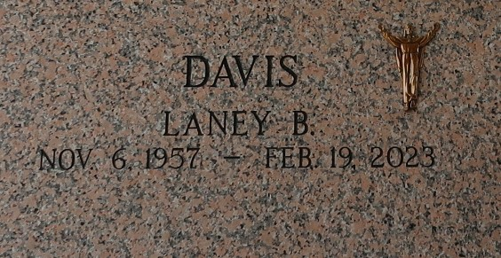

Laney Marie Brown Davis departed this life on Sunday, February 19, 2023 at the age of 65. Daughter of the late Lula Mae Jackson and Adam Brown Jr., wife of Rev. Cedric Davis, mother of Jarius Brown Davis, grandmother of Ermias Lamar Davis, sister of Terry Williams, Sheila Ramsey, Michael and Sabrina Jackson, Lonnie, Roland, and Ronald Brown also the late Andrew Jackson, Leona and the Rev. Donald Brown Sr. Laney is also survived by a host of nieces, nephews, other relatives and friends.

The Celebration of Life service will be held Saturday, February 25, 2023 at 1 pm. at Providence B.C., Hwy. 44, Montz, LA. Viewing from 12 a.m. until service time. Interment

in St. John Memorial Laplace, LA. Professional services entrusted to the caring staff of Hobson Brown Funeral Home, 134 Daisy Street, Garyville, LA 70051, 985-535-2516.

The Times-Picayune, New Orleans, Louisiana

Feb. 24, 2023