Doris Ruth (Bagwell) Delatte

January 22, 1934 – January 25, 2022

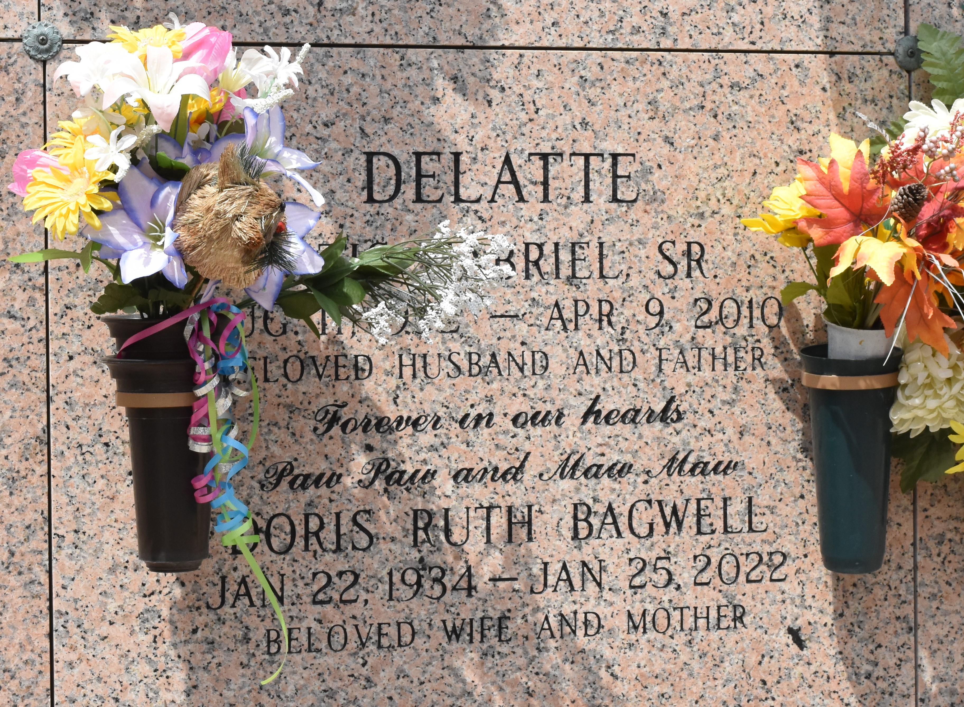

Doris Ruth Bagwell Delatte passed away on January 25, 2022, at the age of 88. Born in Berry, AL to Herman and Eva Mahan Bagwell. She was a long-time resident of LaPlace, LA.

Doris, “Pecky” “Mama” or MawMaw whatever name she was called by her ever growing family and friends was full of life and love for everyone. She always had room for one more. She took in other children when they needed love and care. She cared for her parents and other's parents in their later years. She never ran out of love. She was also an amazing creative spirit. She loved to make “Things”. She sewed, she painted, she did ceramics and wood crafts. She loved collecting tropical plants and driftwood. She loved the swamp and fishing in Grand Isle. She loved Cajun music and dancing. But most of all she loved her husband Otis whom she has joined in heaven for eternity.

She is preceded in death by her beloved husband of 59 years Otis G. Delatte Sr, her eldest son Otis "Pete" Delatte Jr, her parents Herman and Eva Mahan Bagwell as well as her brother Cecil Bagwell and sisters Wilma "Lou" Cotty and Patsy Bell.

Doris is survived by her children and their spouses, Gerald (Marcy) Delatte, Charlotte (Dennis) Torres, Stephen (Trina) Delatte, Ricky (Ellen) Delatte, Timothy (Marlene) Delatte, Leona (Cal) Buras, Wendel (Tracy) Delatte, Tina (Shelby) Pequet, Robert (Betty) Delatte, Danielle (Eric) Louque, Randy (Stacy) Delatte, Thomas (Leah) Delatte, John (Michel) Delatte, Brian (Darcey) Delatte; Debbie (“Pete”) Delatte; and by 55 grandchildren, 88 great-grandchildren, 11 great-great-grandchildren. She is also survived by her sister Wanda "Sue" Bagwell.

A visitation will be held at St. Joan of Arc Church in LaPlace, LA on Friday, January 28, 2022 from 10:30 AM until the Mass of Christian Burial beginning at 12 noon.  Interment will follow at St. John Memorial Gardens in LaPlace, LA.

Rose Lynn Funeral Home, Lutcher, Louisiana