Irene (Guillot) Deroche

April 17, 1925 – November 3, 2007

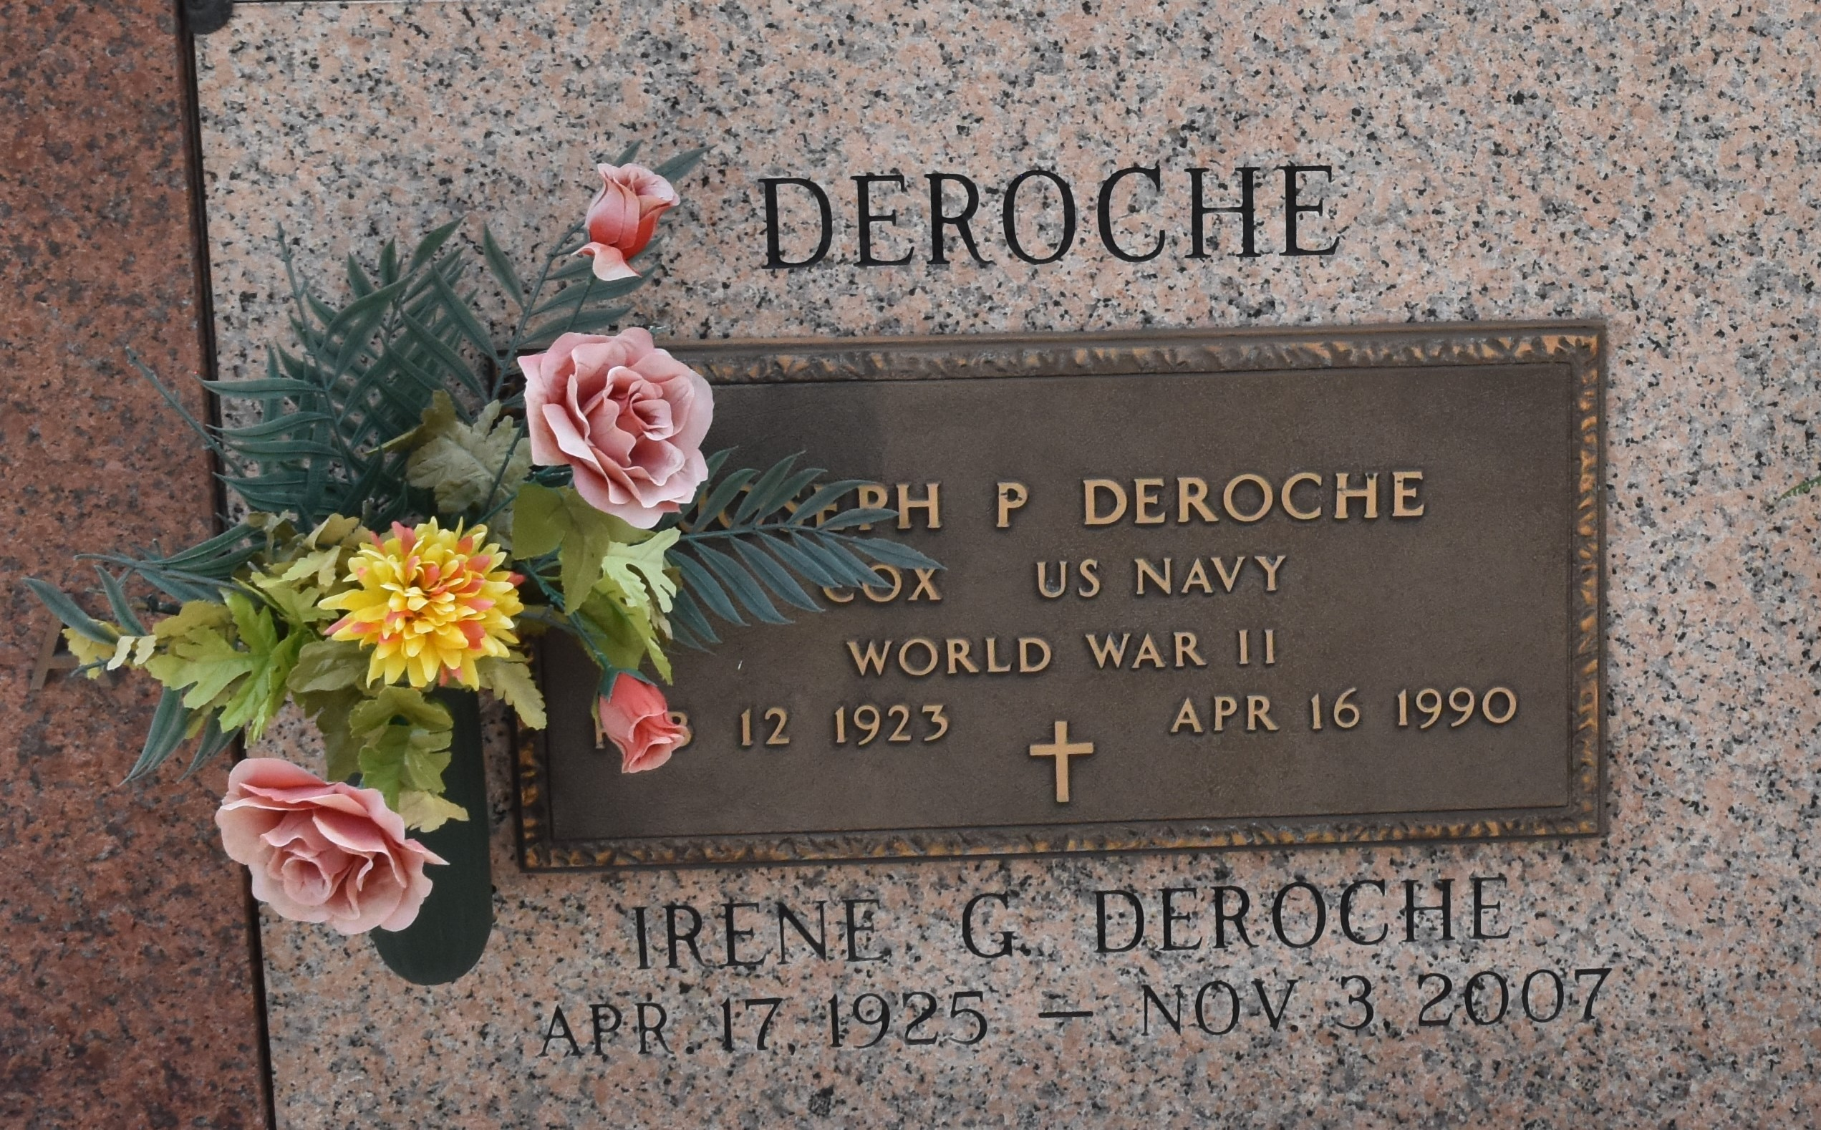

Irene Guillot Deroche on Saturday, November 3, 2007 at 6:30 am. Beloved wife of the late Joseph (Pete) Deroche. Mother of Carolyn Deroche Piediscalzo, Gary, Gerald and Peter Deroche. Also survived by 10 grandchildren and 11 great grandchildren. Daughter of the late Klebert and Elda C. Guillot. Sister of Elma Barrilleaux, Else Engeron and the late Ernest and Lawrence Guillot and Bernice Morvant. Age 82 years. A native of Thibodaux and a resident of LaPlace for the past 42 years.

Relatives and friends are invited to attend services. Visitation at Millet-Guidry Funeral Home in LaPlace, followed by Religious Services at the Funeral Home Chapel. Burial in St. John Mem. Gardens Cemetery, LaPlace, LA.

Times Picayune, New Orleans, Louisiana

Tuesday, Nov 6, 2007