Peter Michael Deroche

November 21, 1952 – November 23, 2021

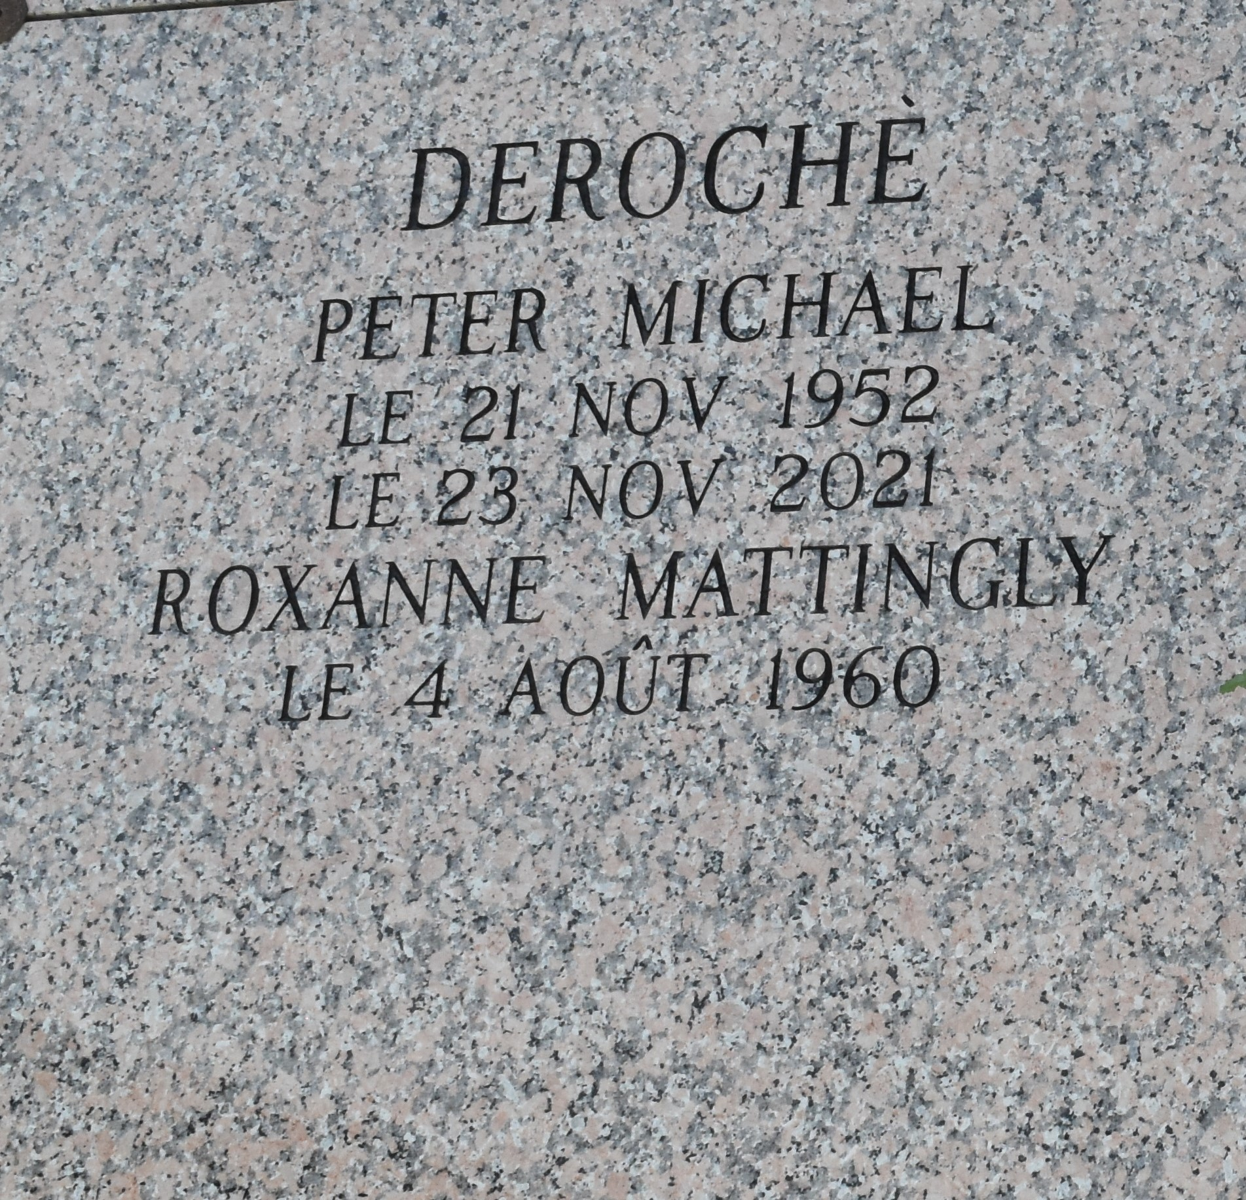

Peter Michael DeRoche, 69, of Moss Bluff, passed away Tuesday, November 23, 2021 in Lake Charles. Services are being conducted by Heritage Funeral Home.

Peter was loved by his wife of 35 years, Roxanne DeRoche; four daughters, Rachael DeRoche, Melissa Richardson & Chris, Sarah Tranter & Collin, and Kelly DeRoche & Ethan Davis; son-in-law Jonathan Landry; seven grandchildren, Wendy Landry, Claire Landry, Maxine Richardson, Marceline Richardson, Liam Tranter, Lilian Tranter, and Henry Tranter; and three siblings, Gary DeRoche & Karen, Gerald DeRoche & Sharon, and Carol Piediscalzo.

He is preceded in death by his parents, Joseph & Irene DeRoche; and brother-in-law John Piediscalzo, Jr.

##### [Heritage Funeral Home, Moss Bluff](https://facebook.com/heritagefuneralsmb?hc_ref=ARSrGY7_lEV2jxAG1bvxf_nxRJC3Y-I1i3q34Hz9AwoM6CsXKIyntkicPZDPNqgcX6g&fref=nf&__xts__%5B0%5D=68.ARACiKyaTO9GLMxQkZC3NZy4iqwiJvqkk2x433RCn58k6DRRi8KujEpeovptPSD9y0WrKoz8afhzQ2YhJQ7EScTBEdP4Z7awSYxGrREE6crg1VQf3cP-fnzpfziJRdqdBhGH96yNlYnyMXt4zWj7bMYwAmVi1ShJsczb3SuN98uexx5W1jDgZr5QOalUkhrCgVriItA43_qloqa2R-ItMdvp8lddYC7weCTo-rqU5gpCkHP4IjzzpehLeKbhW-30I5KvQ-T42L6uBQGZ783CqzMCLSIkryM&__tn__=kC-R), Calcasieu Parish, Louisiana