Shirley Mae (Parquet) Doley

November 30, 1932 – March 16, 2014

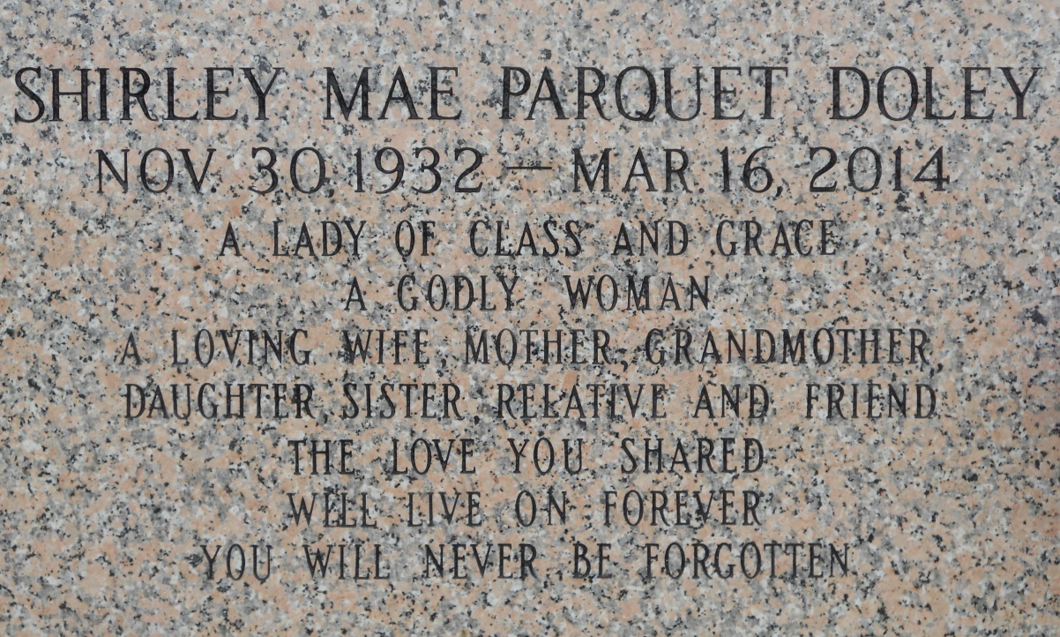

Photo by Team T Lo

Shirley Mae Parquet Doley on Sunday March 16, 2014 at her home in Sunset, LA. Daughter of the late Olevia Robinson and Charles Parquet. Wife of the late Edward Doley, Sr. Mother of Edward Doley, Jr. (Catina) and the late Leon Doley. Sister of Leah Williams, Claire Sharrod, Linda Dunn, Ernest, Sr., Clyde (Mary Ann) and Melvin (Cathy) Parquet, the late Catherine Deterville, Edith, Thomas, Stanley, Sr., Randall, Leonard and Nicholas Parquet. Sister in law of Martha Ann Taylor Parquet and Emily Parquet. Also survived by 1 grandchild Edward C. Doley (Deandra) and a host of nieces, nephews, cousins, other relatives and friends. Age 81 years. A native of LaPlace, LA, a resident of New Orleans for most of her life and moved to Sunset, LA after hurricane Katrina. Relatives and friends of the family, also priest and parishioners of Our Lady of Grace Catholic Church and all neighboring churches are invited to attend the Funeral Mass at Our Lady of Grace Catholic Church, 772 Highway 44, Reserve, LA on Monday, March 24, 2014 at 10:00 AM. Father Christopher Amadi, Celebrant. Interment St. John Memorial Garden Cemetery, Laplace, LA. Visitation at the above named church from 8:15 AM until Mass time. SERVICED BY ROBOTTOM

Times-Picayune, The (New Orleans, LA) - Sunday, March 23, 2014 Contributed by Jane Edson