Richard M. Dowling

May 16, 1949 – April 10, 2009

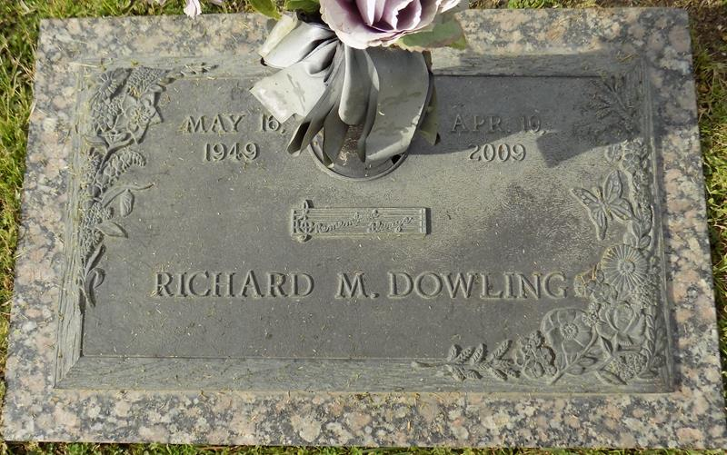

Richard Dowling on April 10, 2009 at 4:40 pm. Beloved father of Sharon Adams. Grandfather of Lilly Adams. Son of the late Lawrence & Lucille Dowling. Brother of Glenn Dowling and Susan Dowling-Miller. Uncle of Christian and Jeremy Fraser and Maggie Miller. Beloved companion of Melody Breaux. Age 59. A native of New Orleans, La. And a resident of LaPlace, La.

Relatives and friends are invited to attend services. Visitation at Millet-Guidry Funeral Home, 2806 W. Airline Hwy. LaPlace, La. On Tuesday April 14, 2009 from 5:00 pm to 8:00 pm. And on Wednesday April 15, 2009 at St. John Memorial Gardens Cemetery, 2205 W. Airline Hwy. LaPlace, La. From 9:00 am to 10:00 am. Followed by a celebration of his life at 10:00 am. Burial in St. John Memorial Gardens Cemetery.

Times-Picayune, The (New Orleans, LA)

Sunday, April 12, 2009