Jules J. Duhe Jr.

July 31, 1966 – May 11, 2020

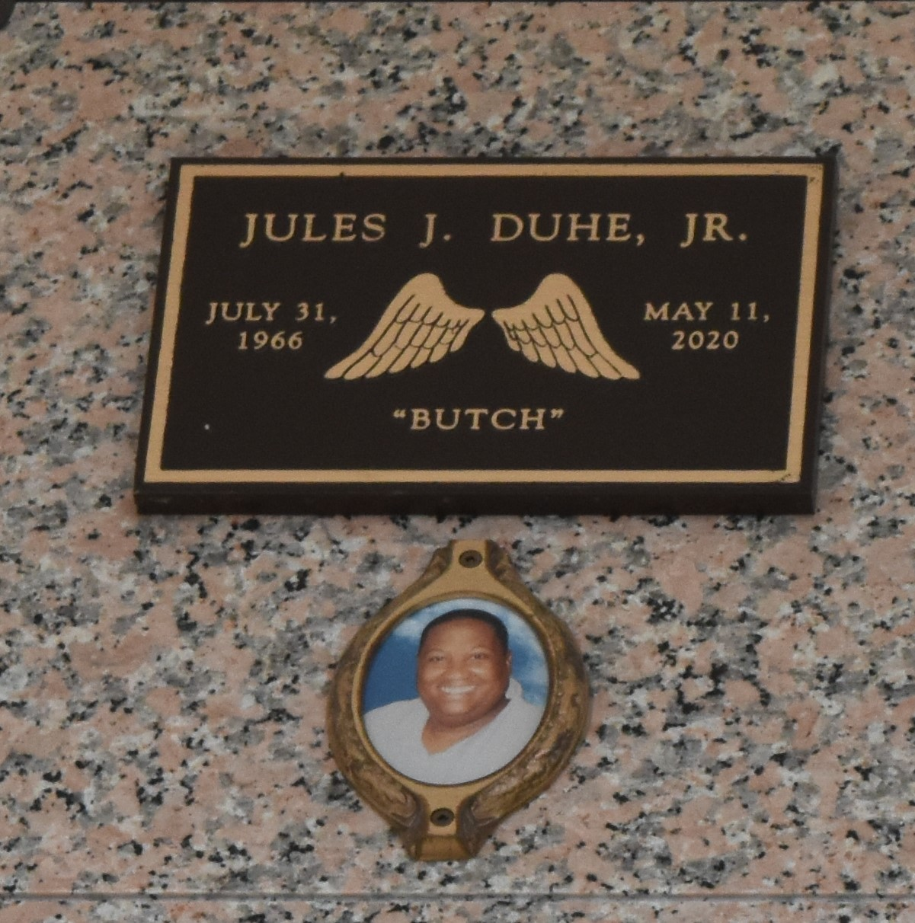

Jules Duhe, Jr., age 53, have fought an excellent fight, he came to the end of his Journey, Jules have Kept the faith. Jules entered the gates of Heaven on Monday, May 11, 2020 at East Jefferson General Hospital. Relatives, friends, employees, Pastors, officers and members of Our Lady of Grace, St. Anna Episcopal Church, Dollar General, Flowers Tax Services and United State Postal Services are invited to attend his viewing on Friday, May 22, 2020, 12:00PM until 1:30PM at Milesville Memorial Church of God, 129 Apple St., LaPlace, LA. Interment Private. PLEASE WEAR MASK.

He was preceded in death by his parents, Mable and Jules J. Duhe, Sr., and 3 siblings, James Sr., Brenda, and Win Ellis Duhe.

He leaves to cherish his memories his 6 siblings, Shirley Jacob, JoAnne (Robert) Gray, Marilyn Flowers, Karen (Lester) Wilson, Lonnie (Deola) and Lyle (Cynthia) Ellis and a host of nieces, nephews, other relatives and friends. Services Entrusted to the Caring Staff of: Professional Funeral Services, Inc., "Celebrating Life" 1449 N. Claiborne Ave., New Orleans, LA 70116. 504-948-7447.

Times Picayune, New Orleans, Louisiana

May 20 to May 22, 2020