Marie (Madere) Duhe

April 5, 1928 – March 3, 2009

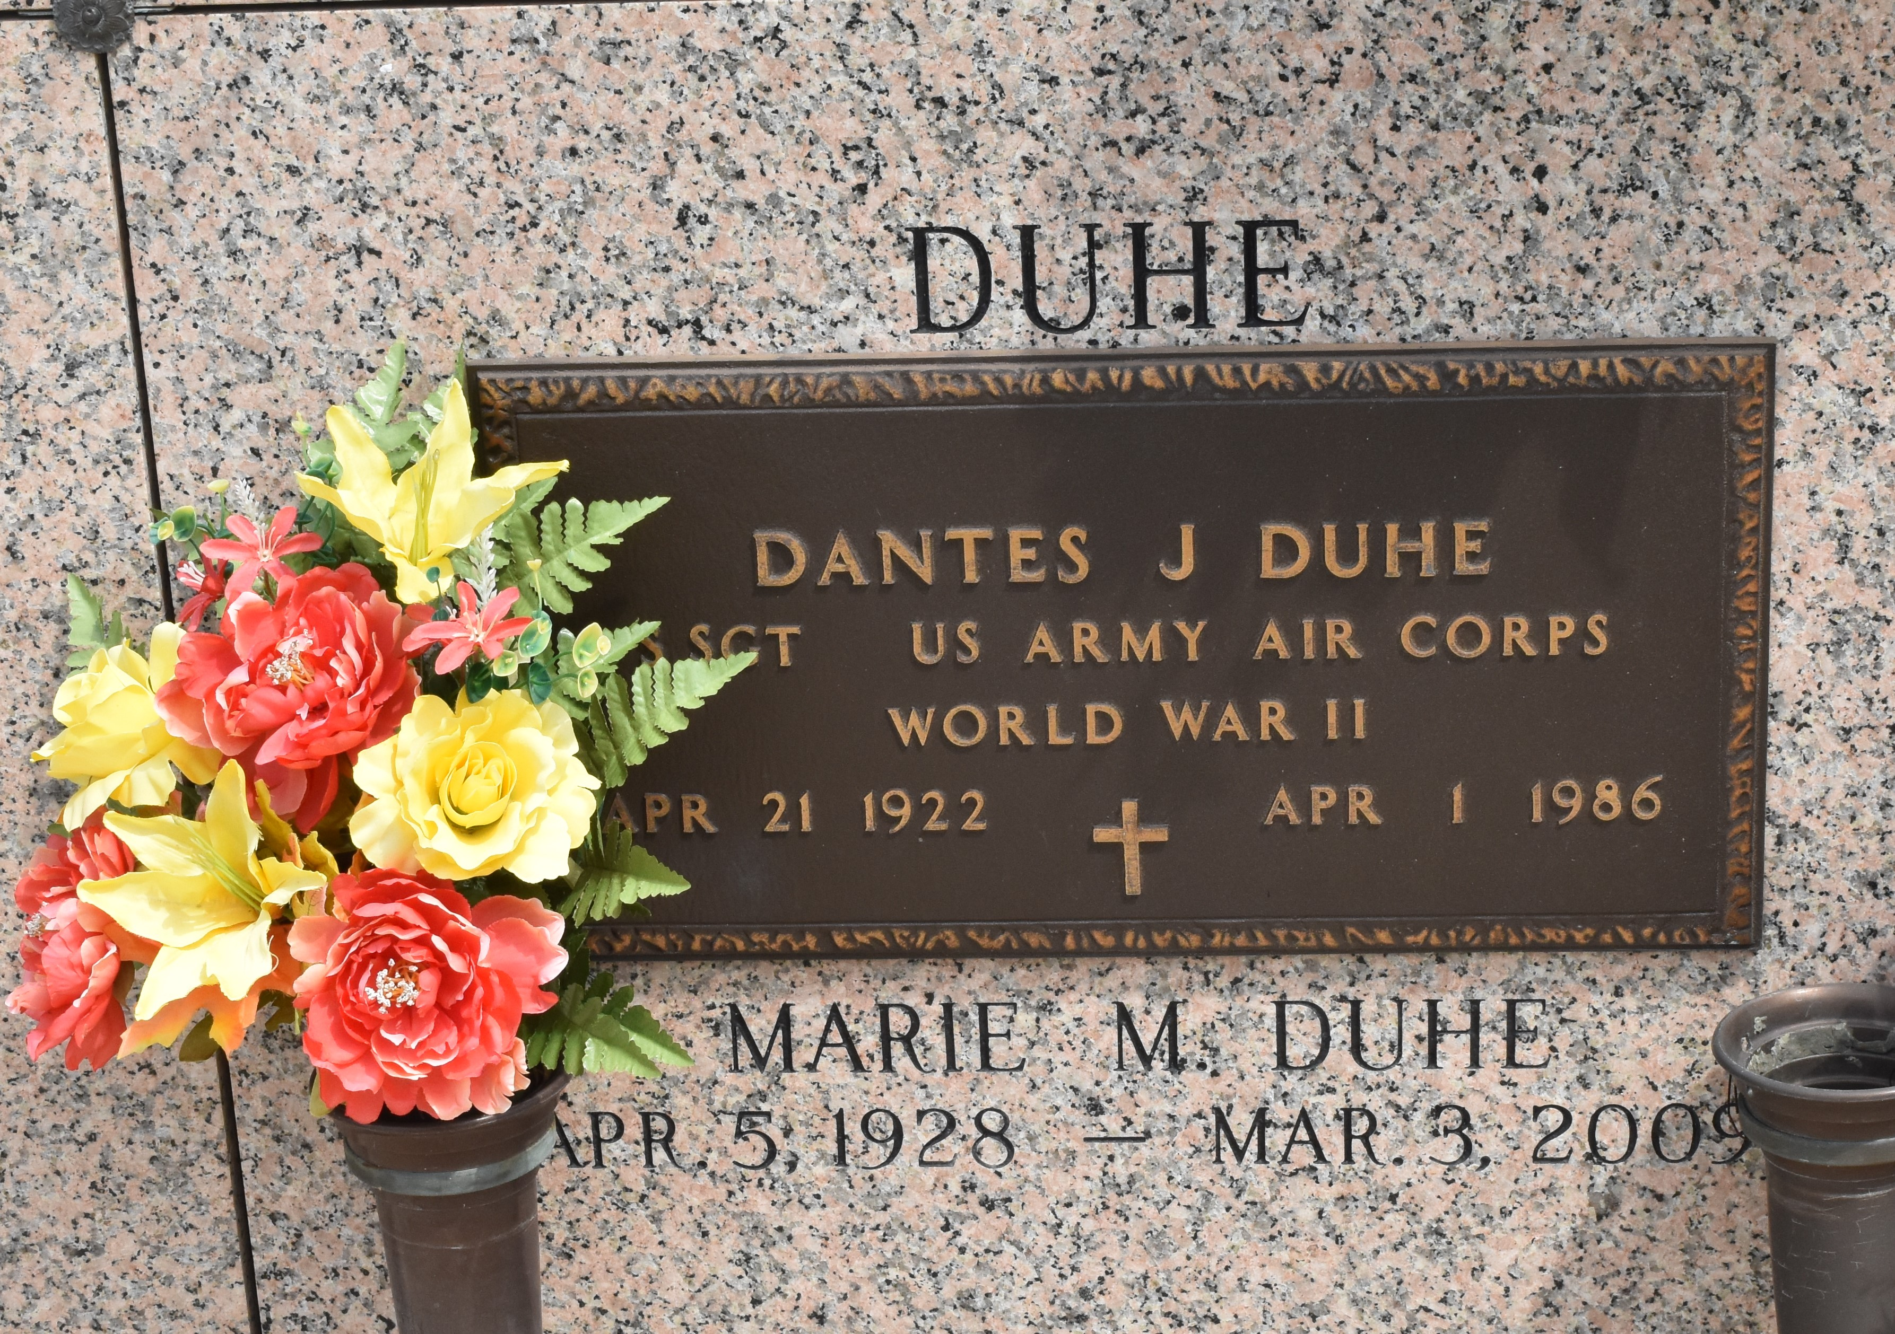

Marie B. Duhe was born on May 5, 1923 in Gramercy, LA. She fell asleep in death at her home on May 27, 2019. She was 96 years of age, a native of Reserve, LA and a resident of LaPlace, LA. She was preceded in death by her husband, Chester Duhe, Sr.; father, Emile Blouin; mother, Julia Roper Blouin; brothers, Edmond Blouin, Jules “J. C.” Blouin; sister, Gertrude Zimmerman; and grandbaby, Gary Bordelon. Left to cherish her memory are her sisters, Marguerite Ziegler, Theresa Crampas; brother, Emile Blouin Jr.; four children, Julie Bordelon (Malcolm), Chester Duhe Jr. (Nancy), Catherine Millet (Glenn) and Paul Duhe (Guia); nine grandchildren; 14 great grandchildren; one great great grandchild; and a world of spiritual brothers, sisters and friends.

The Memorial Visitation will be held at Millet-Guidry Funeral Home, 2806 W. Airline Hwy., LaPlace on Saturday, June 1, 2019 from 10:00 a.m. to 12:00 p.m. with the service to immediatley follow at 12:00 p.m. Inurnment will be held at a later date in St. John Memorial Gardens Cemetery. In lieu of flowers please consider a donation in her memory to your charity of choice.

Millet-Guidry Funeral Home, LaPlace, Louisiana

May 29, 2019