Philip B. Duplessis

March 26, 1920 – December 17, 2009

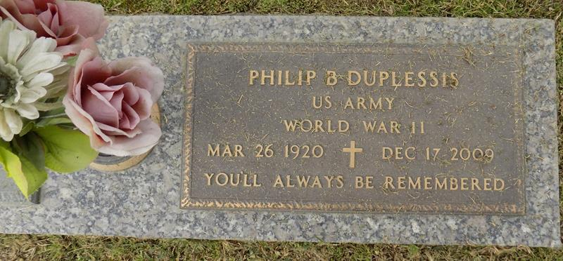

Philip B. Duplessis, age 89. Beloved husband of the late Marie Ethel Duhe Duples-sis. A native of Gonzales, La., resident of New Orleans, La. and a longtime resident of Montz, La. He passed away at the River Region Hospice House in River Ridge, La. on Thursday, December 17, 2009 at 7:30 pm. He was the father of Gene P. Duplessis and wife Mitiz, Alcee Paul Duplessis, Sheryl D. Wilson and husband Chuck and Gary Jude Duplessis, Sr. and wife Earline. He was the grandfather of Gary J. Duplessis Jr. and wife Nicole, Damon Paul Duplessis and wife Brandy, David Gerard Duplessis and wife Renee, Michelle D. Prudhomme and husband Perry Jr. Mindy W. Olsen and husband Shaun, Shannon Wilson and friend Billy and Heather Wilson and friend Joe. He was the great-grandfather of Karah and David Duplessis Jr., Tyler and Avery Duplessis and Blaise Wilson. He was brother to Theresa D. Guedry and husband Roger. He was preceded in death by his siblings: Felma D. Poche, Toby Duplessis, Vernon Duplessis, Joseph Duplessis and Leona Duplessis. Also precede in death by one great-grandchild Bryce Philip Wilson. Philip served his country in the U.S. Army, Company "C" 475th Infantry in Burma India and received Unit Citation, Good Conduct Medal, American Defense Service Medal with one Bronze Star. He also served duty in the Philippines and Panama. He was employed by Maison Blanche for 19 years. Retired as a heavy equipment operator employed by St. Charles Parish. He was a member of V.F.W. Post #3337 in LaPlace. His favorite pastimes were Barb-be-que cooking at home, dancing, playing the harmonica and singing French songs. The family wishes to thank the staff and employees of the River Parishes Hospital and River Region Hospice house for their kindness and caring through this difficult time. Relatives and friends are invited to attend services. Visitation at Millet-Guidry Funeral Home, 2806 W. Airline Hwy. LaPlace, La. on Monday, December 21, 2009 from 10:00 am to 11:45 am. Followed by a Mass of Christian Burial at St. Joan of Arc Catholic Church, LaPlace at 12:00 noon. Burial in St. John Memorial Gardens, LaPlace, La.

Times-Picayune, The (New Orleans, Louisiana)

Sunday, December 20, 2009  
Contributed by Jane Edson