Harvey G. Einhart

August 27, 1924 – June 8, 2006

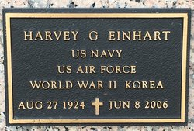

Photo by Team T Lo

Harvey G. Einhart on Thursday, June 8, 2006 at 1:00 a.m. Beloved husband of Esther Belvajean Einhart. Father of Dana Todd of River Falls, AL and James Einhart of Pensacola, FL. Son of the late Harvey A. and Nora Einhart of OH. Also survived by 4 grandchildren and 3 great-grandchildren. A retired Navy Chief and Chief Engineer of Continental Airlines and Chief Engineer of LaPlace Volunteer Fire Dept. since 1994. Age 81 years. A native of New York and a resident of LaPlace, LA for the past 34 years.  
 Relatives and friends of the family are invited to attend services. Visitation at MILLET-GUIDRY FUNERAL HOME, 2806 W. Airline Hwy., LaPlace, LA on Monday, June 12, 2006 from 5:00 p.m. until 7:00 p.m. Followed by Religious Services at the Funeral Home Chapel at 7:00 p.m. Burial to be private at a later date.  
 In lieu of flowers, donations preferred to the LaPlace Volunteer Fire Dept.

**Times-Picayune, The (New Orleans, LA) - Sunday, June 11, 2006**

**Contributed by Jane Edson**