Mildred (Rushing) Englade
October 22, 1930 – June 21, 2014

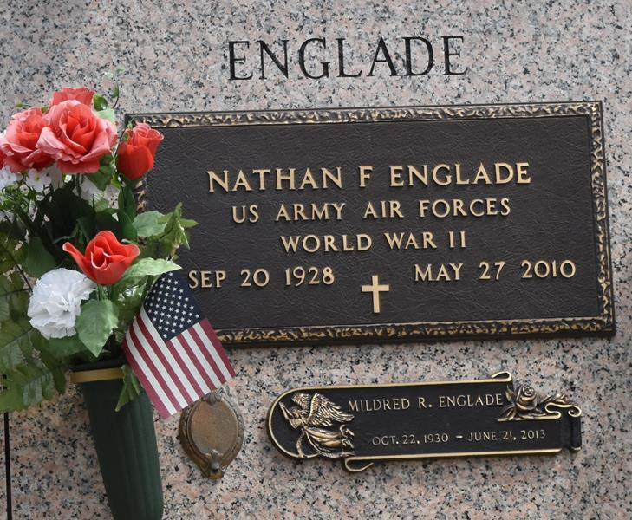

Mildred Rushing Englade died on Friday June 21, 2013. Beloved wife of the late Nathan Englade. Mother of Jody (Jackie) and Mark (Valerie) Englade and the late Dwayne Englade (Peggy). Also survived by 8 grandchildren (2 deceased), 13 great-grandchildren and 1 great-great-grandchild. Daughter of the late Henry and Denise Rushing. Sister of Doris Tramonte and the late John (JBoy) and Lloyd (Buckie) Rushing. Age 82. A native and a resident of LaPlace.
Relatives and friends are invited to attend services. Visitation at Ascension of Our Lord Catholic Church, 1809 Greenwood Dr, LaPlace, LA on Tuesday June 25, 2013 from 9:00am to 11:00am, followed by Mass at 11:00am. Burial in St. John Memorial Gardens Cemetery, LaPlace.
Special thanks to Emily Parquet and Iris Perilloux Palermo for their loving care of our mother. Arrangements by Millet-Guidry Funeral Home, LaPlace, LA.

Advocate, The (Baton Rouge, LA)
Saturday, June 22, 2013
Contributed by Jane Edson

