Nathan F. Englade
September 20, 1928 – May 27, 2010

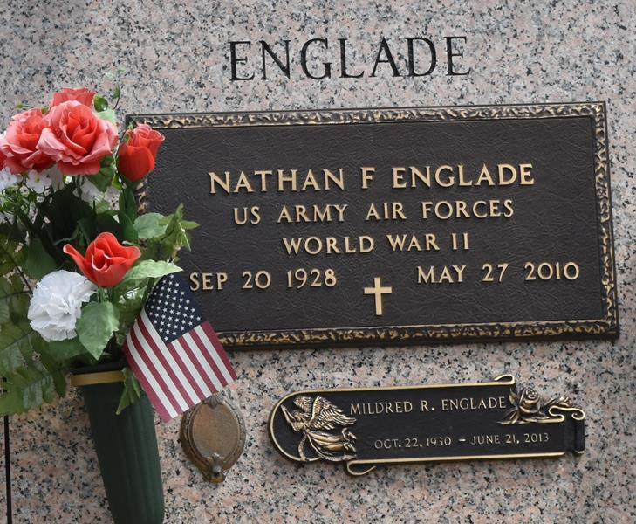

Nathan F. Englade passed away on Thursday, May 27, 2010. Beloved husband of Mildred Rushing Englade. Father of Jody and Mark Englade and the late Dwayne Englade. Also survived by 8 grandchildren (2 deceased) and 7 great-grandchildren. Brother of the late Norman Englade and Thelma Jaubert. Age 82. A native of Reserve and a resident of LaPlace.

Relatives and friends, also members of the Knights of Columbus are invited to attend services. Visitation at St. Joan of Arc Catholic Church, LaPlace, La. on Saturday, May 29, 2010 from 9:00 am to 11:00 am. Followed by a Mass at 11:00 am. Burial in St. John Memorial Gardens Cemetery, LaPlace, La. Arrangements by Millet-Guidry Funeral Home, LaPlace, La.

The Times-Picayune, New Orleans, Louisiana
May 28, 2010

