Lorenzo R. Eugene
1984 – November 18, 2018

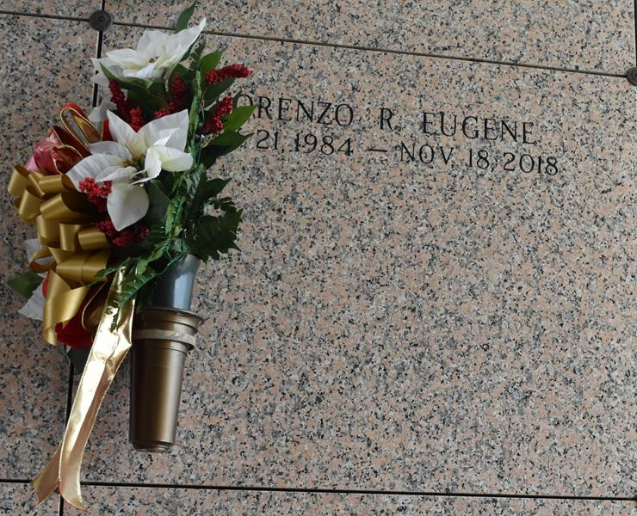

Lorenzo Eugene, 34, passed away on Sunday, Nov. 18, 2018.
He was a resident of Garyville. He was the son of Sharon Eugene and the late Steve Warren; and the beloved father of Za’Kyja King, Jakoz King and Rylee Guff.
He is survived by his mother, children and a host of aunts, uncles and cousins.
His Homegoing Celebration Service will be at 11 am. Saturday, Nov. 24 at Bethlehem Missionary Baptist Church, 146 East 20th St. in Reserve. Burial will immediately follow services.
L’Observateur, LaPlace, Louisiana
Wednesday, November 21, 2018

