Paul Joseph Eugene

March 31, 1956 – March 31, 2008

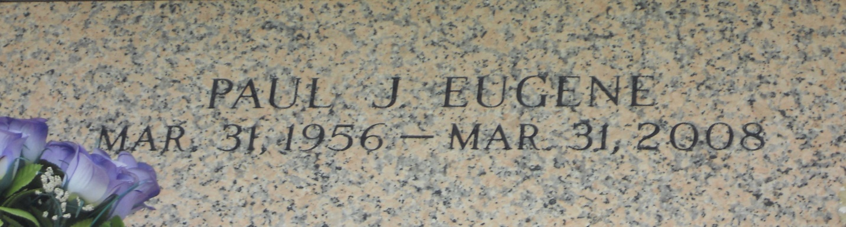

Photo by Team T Lo

Paul Joseph Eugene, a native of Garyville, La. and a resident of LaPlace, La., age 52, departed this life on Monday, March 31, 2008 at River Parishes Hospital, LaPlace, La. Beloved husband of Suzanne Robinson Eugene. Step-father of Courtney and Chloe. Brother of Michael, Donald, Kenneth, Floyd Eugene, Barbara Eugene, Lorraine Sanders, Laura Eugene, JoAnn Lewis and Sharon Eugene and the late Herman Jr. and Charles Eugene. Preceded in death by parents, Rev. Herman and RoseMary Eugene.  
  
Relatives and friends of the family, also Pastor, officers and members of the New Hopeful B.C., Garyville, La. and employees of St. John Housing Authority are invited to attend the Funeral Services on Saturday, April 5, 2008 at 11:00AM from the New Hopeful B.C., So. Fig St., Garyville, La. Rev. Roland Morgan officiating. Entombment St. John Memorial Gardens, LaPlace, La. Visitation on Friday, April 4, 2008 from 5-7pm from the Baloney Funeral Home, 399 Earl Baloney Dr., Garyville, La., and on Saturday at the church after 9:00am.  
  
The Baloney Funeral Home LLC, 399 Earl Baloney Dr., Garyville, La. 70051, 985-535-2540 In charge of arrangements.

Times-Picayune, The (New Orleans, LA) - Friday, April 4, 2008

Contributed by Jane Edson