Bessie Ray (Branham) Evans
November 14, 1922 – October 1, 2014

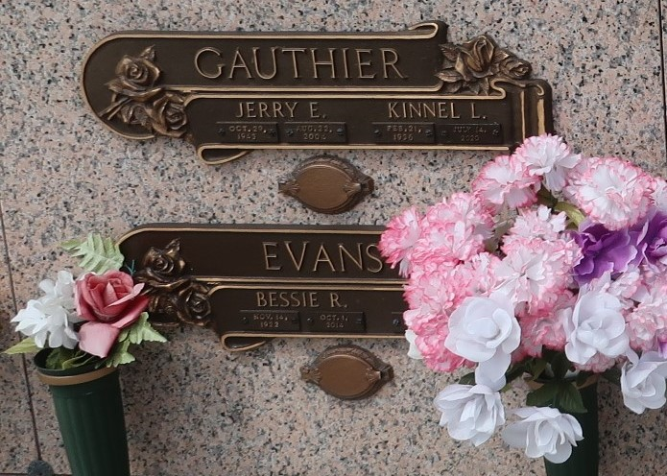

Bessie Ray Branham Evans passed away in the presence of her family on Wednesday, October 1, 2014. She was 91, a native of Silsbee, TX and a resident of LaPlace. Beloved wife of Jack O. Evans. Mother of the late Jerry Dee Gauthier. Mother-in-law of Kin L. Gauthier. Daughter of the late Bessie Shackelfer and George H. Branham. Grandmother of Chantelle Epperly (husband, Dennis) and Chadna Gauthier (husband, Ryan). Great-grandmother of Dustin and Alysa Epperly and Tyler Gauthier.

Relatives and friends are invited to attend the Funeral Service in the Chapel of Millet-Guidry Funeral Home, 2806 W. Airline Hwy., LaPlace on Friday, October 3, 2014 at 11:00 a.m. Visitation from 9:00 a.m. until 11:00 a.m. Interment in St. John Memorial Gardens Cemetery.

Unknown source

