Rodney A. Evans, Sr.
September 27, 1951 – December 13, 2022

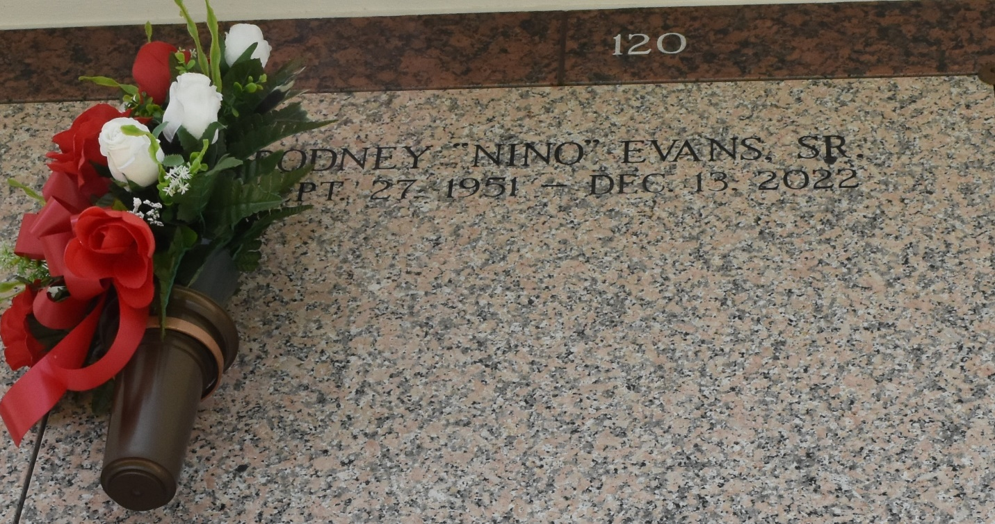

On September 27, 1951 a baby boy was born in New Orleans, LA. To the late Ethel Mae Morris and Elza Lee Evans, Sr. Rodney peacefully entered into eternal rest on Tuesday December 13, 2022 at the age of 71. Rodney was the father of Rodney Evans, Jr. (Courtney) and the late Elza Evans, IV. The grandfather of Rodney “Tre” Evans, III. The husband of the late Pamela Carr
Evans.
Rodney was educated in the St. John the Baptist Parish School System and was a proud alumnus of Fifth Ward High School. Rodney worked as a scaffold Builder for many years at several River Parish Refineries. He accepted Christ as his Lord and Savior and was baptized at Power House
Christian Church in Laplace, LA. He later became a faithful member of First Antioch Baptist Church in Gramercy, LA. where he served as an Usher.
Rodney was known as “Nino” and “The Watermelon Man” to his friends and family. He loved to dance and was known as the “Dancing Usher down the aisles” by his fellow church members. His laugh was like no other! Rodney had The Gift of Gab! He was born with a giving spirit so if he had it, you had it! He enjoyed watching the Greenbay Packers on Sundays and He loved fishing but would always give his daily catch away. Nino knew someone for everything you could ever need, rather it was an item or a service, he had the connection. 1 call that’s all! Rodney lived the life he truly Loved.
He leaves to cherish his many precious memories, His 1st born Son Rodney Evans, Jr. (Courtney), Only beloved Grandson Rodney “Tre” Evans, III. Loving Sister and Caretaker JoAnn Morris Alexander, Devoted Brother Raydel Morris Sr. (Dawn), Aunts Martha Parquet and Audrey Johnson. Nephews Averell “Mousie” Smith (Jada) and Raydel “Snoopy” Morris, Jr. (Michelle),
Nieces Ashanti Gooden (Jimmie) and Raykael Morris along with a Host of Great Nieces, Great Nephews, Friends, and Family.
Rodney was preceded in death by his Mother Ethel Mae Morris, Father Elza Lee Evans, Sr. His brother Kevin Gray. Son Elza Lee”Noonie” Evans, IV. And his Infant Daughter Tamekia "Chocolate" Evans.
A celebration of life honoring Rodney Evans, Sr. will be held on December 19, 2022, at First Community Antioch Baptist Church, 10860 Hwy 3125, Gramercy, LA 70052. Visitation will begin at 9am. Service will begin at 11am. Interment to follow at St. John Memorial Gardens Cemetery in Laplace, La.
Final care and professional services entrusted to Treasures of Life Funeral Services, 315 E Airline Hwy., Gramercy, LA 70052.

Treasures of Life Funeral Services, Gramercy, Louisiana

