Alonzo L. Faucheux III

December 27, 1930 – May 2, 2009

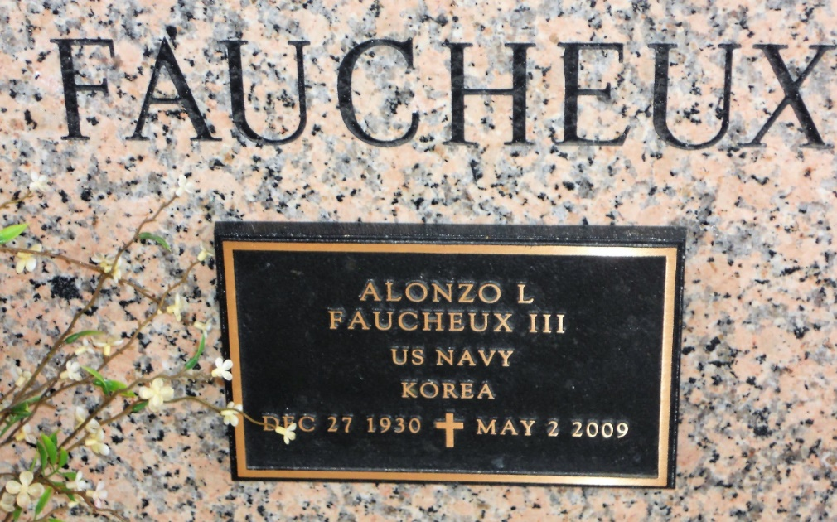

Photo by Team T Lo

Alonzo Louis "Al" Faucheux III passed away at his home on Saturday, May 2, 2009 after an extended illness. He was a loving husband, dedicated father, and a proud "Poppa" to his grandchildren. Mr Faucheux served in the US Navy during the Korean War and was a long-time employee of DuPont before retiring in 1990. To cherish his memory, he leaves his loving wife of 54 years, Jane Fernandez Faucheux; his devoted children and their spouses: Lonnie and Susan Faucheux, John and Nancy Faucheux, Alicia and Stan Vial, Yvette and Jacques Levet, and Stephanie and Larry Bleakley; his 12 grandchildren and 8 siblings: Isabel Harrell, Rose Navarro, Aimee Boudreaux, Don Faucheux, Carol Dicharry, Florette Podufalski, Gaston Faucheux, and Anne Haydel. His parents, Alonzo Louis and Isabel Menuet Faucheux, preceded him in death. He will also be remembered fondly by his many other relatives and family friends. The family wishes to give special thanks to his wonderful caregivers who have helped throughout his long illness. Services were Wednesday, May 6, St Joan of Arc Catholic Church in LaPlace with interment at St John Memorial Gardens, Airline Hwy, LaPlace.

The Times-Picayune, New Orleans, Louisiana

4 May 2009