Pauline (Borne) Felton
February 9, 1925 - April 16, 2001

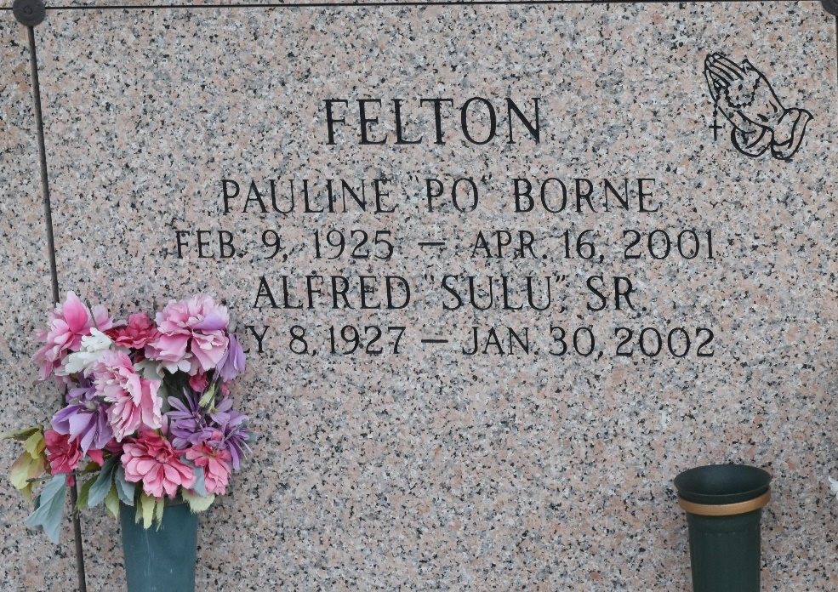

Pauline B. Felton, 76, a native and resident of Garyville, died April 16. She was the wife of Alfred Felton Sr. and mother of Mary Harvey, Kim Jones, Alfred Jr., Kerry, Claudette and Michelle Felton, and the late Paulette and Brenda Felton. She was also the daughter of the late Edgard Sr. and Mary Borne, and sister of Catherine, Ellis, Edgard II and Raymond Borne. She is also survived by eight grandchildren.
Services are today at 10 a.m. at St. Hubert Catholic Church, Garyville, with interment at St. John Memorial Gardens, LaPlace. Visitation starts at 8 a.m.
L'Observateur, LaPlace, Louisiana
April 18, 2001

