Jerome Brian Fobb
March 2, 1962 – March 13, 2019

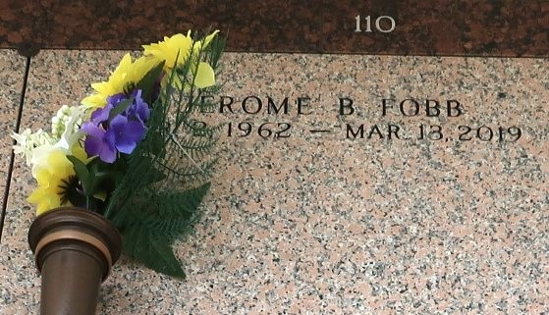

Jerome Brian Fobb, age 57, departed this life on Wednesday, March 13, 2019. Son of the late Herfert and Onie B. Fobb. Father of Antjuanya, Ankia, Jeremy, and the late Jerome James Jr. Brother of Herfert Fobb Jr, Vader Wilson, Claudia, Peggy, and Stuart Fobb. Survived by a host of other relatives and friends.

Celebration service will be held on Saturday, March 23, 2019 at 11:00am at the Rising Star B.C., 620 Cardinal St, LaPlace, LA 70068. Rev. Donald August Pastor, officiating. Viewing from 9:00am until service time. Interment St. John Memorial gardens LaPlace, La. Professional Services entrusted to the caring staff of Hobson Brown Funeral Home, 134 Daisy St., Garyville, LA 70051. 985-535-2516.

TheNewOrleansAdvocate.com
Mar. 21 to Mar. 23, 2019

