Rev. Lenord Alex Fobb, Sr.

November 17, 1947 – August 21, 2008

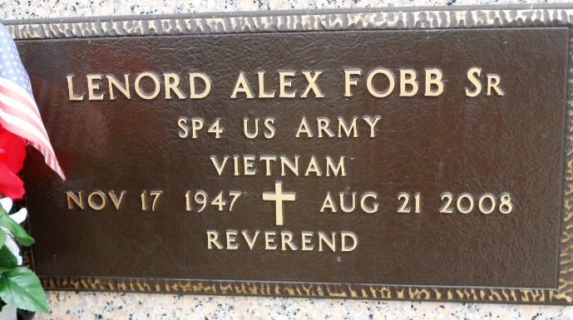

Photo by Team T Lo

Rev. Lenord Alex Fobb, Sr. (Narchy), of LaPlace, LA, departed this life peacefully at River Parishes Hospital on Thursday, August 21, 2008 at 7:30 p.m. Age 60 years. Son of Herfert and Once Bazile Fobb. Father of Euradel and Lynell Fobb of LaPlace, LA and Rev. Lenord A. Fobb, Jr. (Travona) of Garland, TX. Grandfather of Janaya, Trenord and Trenan Fobb. Brother of Herfert, Larry, Vader, Claudia, Cornelius, Peggy and Jerome Fobb of LaPlace, LA, Stuart (Joyce) Fobb of Snellville, GA and the late Kevin Fobb. Preceded in death by 1 sister-in-law, 1 nephew and 2 nieces, Also survived by a host of nieces, nephews, aunts, uncles, cousins and friends. A native and resident of LA. He was a resident of Twin Oaks Nursing Home but at the time of his death he resided at South East LA War Veteran Home in Reserve, La.  
  
Funeral Services will be held on Saturday, August 30, 2008 at 11:00 a.m. at the Rising Star Baptist Church, 620 Cardinal St., LaPlace, LA. Rev. Donald August, officiating. Visitation at the Church after 9:00 a.m. Entombment St. John Memorial Gardens, LaPlace, LA.  
  
The Baloney Funeral Home, LLC, 399 Earl Baloney Dr., Garyville, LA 70051  
Information: (985) 535-2540

Times-Picayune, The (New Orleans, LA)

Friday, August 29, 2008

Contributed by Jane Edson