Mavis P. Fobb

January 31, 1936 – May 25, 2011

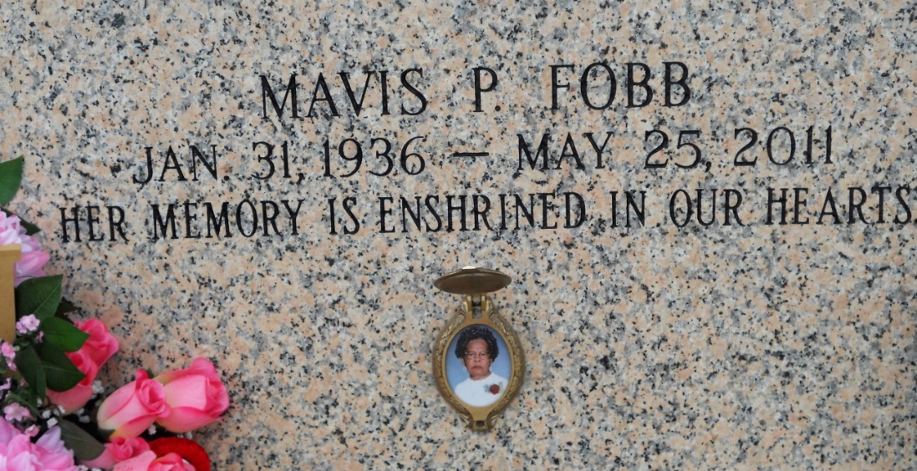

Photo by Team T Lo

Mavis Perrilloux Fobb passed away on Wednesday, May 25, 2011 at her home in Reserve, LA. Daughter of the late Edward Perrilloux and Elizabeth Cook Perrilloux. Beloved Wife of Roy Fobb. Loving Mother of Monica P. Gray (Royal), Raynell Perrilloux, Claudette P. Edwards, Elroy Perrilloux (Linda), Gaynell P. Gauff (Eric), Kenneth Perrilloux (Yvette), Sherman Fobb (Tracy), Dorlisa Fobb, Rico Fobb (Teneka) and Aisha F. Mealey (Rondell). Sister of Richard Perrilloux, Elliot Cook, the late Edwin, Anderson and Ferdinand Perrilloux, Leatrice Young, Verna Cosey and Donna Kendrick. Also survived by 24 grandchildren, 5 great grandchildren and a host of nieces, nephews, other relatives and friends. Age 75 years. A native and resident of Reserve, LA. Relatives and friends of the family, also priests and parishioners of Our Lady of Grace Catholic Church and all neighboring churches are invited to attend the Mass of Christian Burial at Our Lady of Grace Catholic Church, 772 Highway 44, Reserve, LA, on Tuesday, May 31, 2011 at 11:00 AM. Fr. Joseph Rodney, Celebrant. Interment: St John Memorial Garden Cemetery, LaPlace, LA. Visitation at the above named church from 9:00 AM until Mass time. SERVICED BY ROBOTTOM  
  
The Times-Picayune, New Orleans, Louisiana

May 30, 2011