Wayne Morris Forsythe Sr.
July 12, 1942 - December 19, 2019

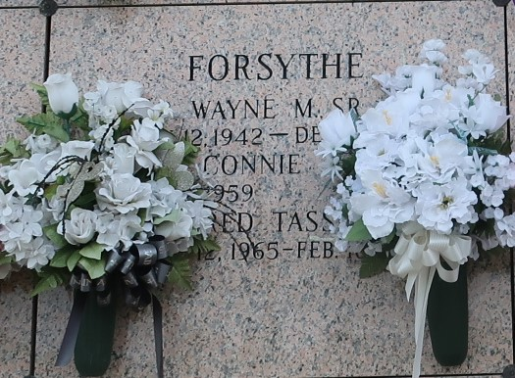

Wayne M. Forsythe, Sr. passed away on Thursday, December 19, 2019 at the age of 77. He was born in Lutcher, LA, was a resident of LaPlace, LA for most of his life and was a recent resident of Ponchatoula, LA. Beloved husband of Connie Tassin Forsythe. Loving father Wayne Forsythe, Jr., Aaron Forsythe (Patty), Stacey F. Brennan (Joseph) and Abby Forsythe. Grandfather of Amanda, Heidi, Tabitha, Melodie, Chelsea, Lindsey, Austin, Shelby, Bailey and Kailey. Great-grandfather of Brady, Brennan, Sage, Jaxon and Jake. Son of the late Florence Catoire Forsythe and Henry Forsythe, Jr. Brother of Farrel Forsythe (Barbara). Also survived by nieces and nephews. Wayne loved being on the water and will be sadly missed by his bowling family.
Relatives and friends are invited to attend the Funeral Mass at Millet-Guidry Funeral Home, 2806 W. Airline Hwy., LaPlace on Monday, December 23, 2019 at 11:00 a.m. Visitation will be held from 9:00 a.m. until 11:00 a.m. Interment in St. John Memorial Gardens Cemetery.

Millet-Guidry Funeral Home, LaPlace, LA
December 20, 2019

