Albert Foster
February 11, 1944 – February 18, 2013

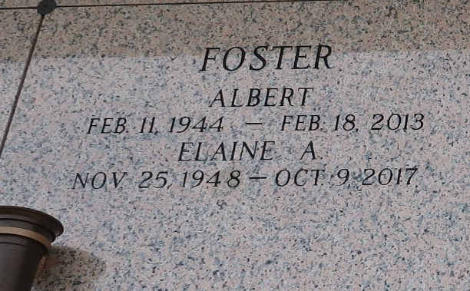

Albert "Do L-Lee" Foster departed this life on Monday, February 18, 2013 in Plaquemine, LA. Beloved husband of Elaine Foster. Father of Kendrick and Chandler Foster.
Services will be held on Saturday, February 23, 2013 at Zion Travelers B.C., 713 Walnut St., LaPlace, LA 70068 at 11:00am. Viewing from 9:00am until service time ONLY. Pastor Julius E. Ellis Sr. officiating. Internment: St. John Memorial Gardens, LaPlace, LA. Service Entrusted To Hobson Brown Funeral Home, 134 Daisy St/P.O. Box 61, Garyville, La (985) 535-2516.

The Times-Picayune, New Orleans, Louisiana
Feb. 20 to Feb. 22, 2013

