Joseph Francisco Sr.
- - September 28, 2021

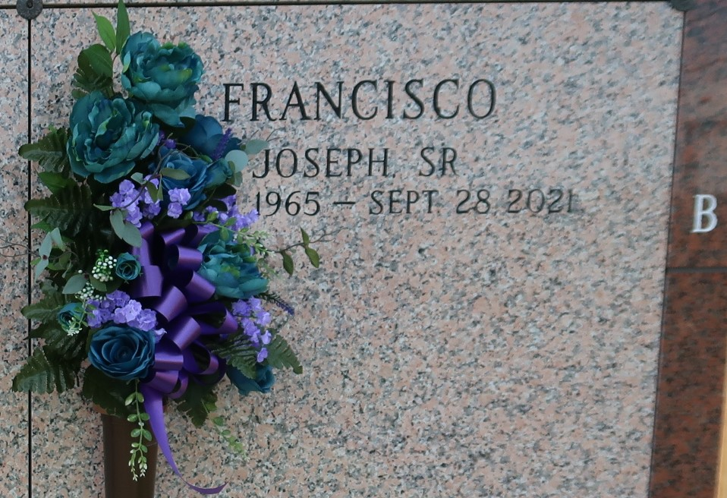

Joseph "Joe" Francisco, Sr. passed away on Tuesday, September 28, 2021 at the age of 55. He was a native of Fairbanks, AK and a resident of LaPlace, LA.
Loving husband of the late Deborah "Kay" Francisco. Beloved father of Joseph "Joe" Francisco, Jr. (Jessica), Paige Francisco, and Amanda Roccaforte (Jeffery). Grandfather of Janie Roccaforte. Loving son of Pedro Francisco and Coralia Francisco. Brother of Felix Francisco. Also survived by his fiancée and companion, Judy Spencer.
Relatives and friends are invited to attend the visitation at Millet-Guidry Funeral Home, 2806 W. Airline Hwy., LaPlace on Saturday, October 9, 2021. Visitation from 9:00 a.m. to 10:30 a.m. followed by a Funeral Service at 10:30 a.m. Interment in St. John Memorial Gardens Cemetery. To share memories or condolences, please visit www.milletguidry.com.
Millet-Guidry Funeral Home, LaPlace, Louisiana
October 15, 2019

