Leborah Francois

August 26, 1943 – April 12, 2010

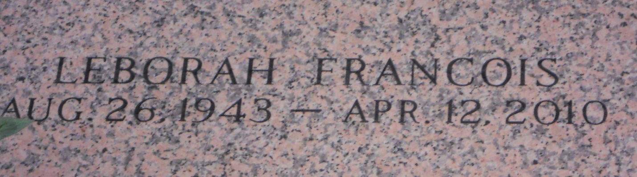

Photo by Team T Lo

Leborah Francois, age 66, departed this life on Monday, April 12, 2010 in Metairie, La. Daughter of the late Gustave (Jack) and Laura (Baker) Howard. Mother of Clarence, Alicia, Marvin, and Timothy (Rose) Francois Sr., and Penny Howard. Sister of Gladys Joseph, Easter Howard, Isabella Gerard, Helen Vampran, Deloris Millet, Joyce Brown, Barbara Breaux, Rosemary Perilloux and Dr. Rev. Freddie Howard Sr. Also survived by 8 grandchildren, 1 sister-in-law, 5 brothers-in-law, a host of nieces, nephews, cousins, and friends. A native of Lucy, La. and a resident of LaPlace, La.  
  
Pastors, officers, and members of Mr. Calvary B.C. and all neighboring churches are invited to attend the Funeral Service on Monday, April 19, 2010 at 11:00a.m. at the above name church, 127 W. 3rd St., LaPlace, La. Dr. Rev. Freddie Howard, Sr., Pastor - Officiating. Visitation at the church from 9:00a.m. until service time. Interment in St. John Memorial Gardens Cemetery LaPlace, La.  
  
Professional Service Entrusted to Hobson Brown Funeral Home, Garyville, La 70051, (985) 535-2516

Times-Picayune, The (New Orleans, LA)

Sunday, April 18, 2010

Contributed by Jane Edson