Nelson Frank
1958 – January 2, 2020

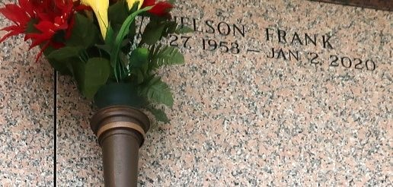

Nelson Frank, age 66, a native of Trinidad, passed on Thursday, January 2, 2020. Son of the late Sylvester and Sylvia Frank, Husband of Gemma Frank, Father of Dian Frank Duronslet, Devin, and Norelle Frank, Brother of Cheryl Nelson, Valentine, Anthony, Garnett, Michael, Ronald, and Andrenette Frank. Nelson is also survived by 2 grandchildren Isabella and Ayden
Duronslet, a devoted friend Leslie Brown, and a host of other relatives and friends.

Celebration Service will be held on Saturday, January 11, 2020 at Tchoupitoulas Chapel 1022 La. Hwy 44 Reserve, LA 70084 at 11:00 am. Viewing on Saturday from 9 – 11 am. Rev. Lionel Murphy Pastor Officiating. and on Friday at M.M. C.O.G.I.C. 129 Apple St. Laplace. Interment in St.
John Memorial Laplace, La. Service entrusted to Hobson Brown Funeral Home, 134 Daisy Street, P.O. Box 61, Garyville, LA 70051.

The Times-Picayune, New Orleans, Louisiana
Jan. 10, 2020

