Terry Lee Franklin

July 12, 1966 – March 22, 2016

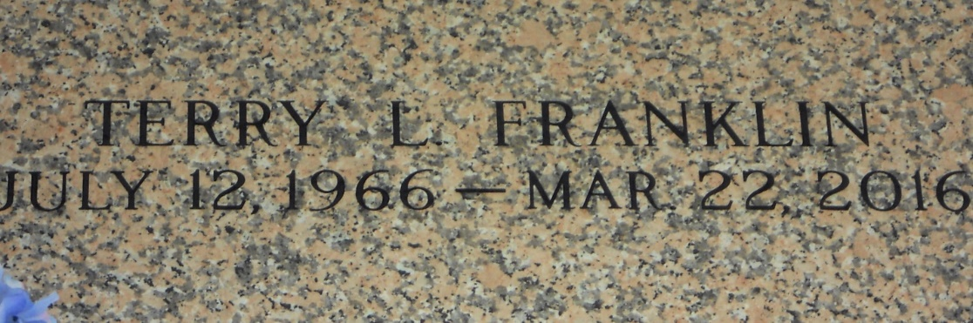

Photo by Team T Lo

Terry Lee Franklin on Tuesday, March 22, 2016 at Ochsner Medical Center, Jefferson, LA. Son of Ella Mae Fiffie and Rev. Isiah Franklin, Jr. Husband of the late Karen Sue Franklin Father of Terri Le'Jaune Franklin and Daniel Levi Franklin Brother of Kevin Franklin and Donna Franklin Also survived by 1 grandchild and a host of aunts, uncles, nieces, nephews, cousins, other relatives and friends. Age 49 years. A native of Hahnville, LA and a resident of LaPlace, LA. Relatives and friends of the family, also pastors, officers and members of Mount Zion Baptist Church and all neighboring churches are invited to attend the Funeral Service at Mount Zion Baptist Church, 100 Second Street, St. Rose, LA on Wednesday, March 30, 2016 at 10:00 AM Rev. Isiah Franklin, Pastor. Interment St John Memorial Garden Cemetery, LaPlace, LA. Visitation at the above named church from 8:00 AM until Service Time

Times-Picayune, The (New Orleans, LA)

Saturday, March 26, 2016

Contributed by Jane Edson