Letitia (Kinsey) Fruge

January 25, 1939 – May 14, 2020

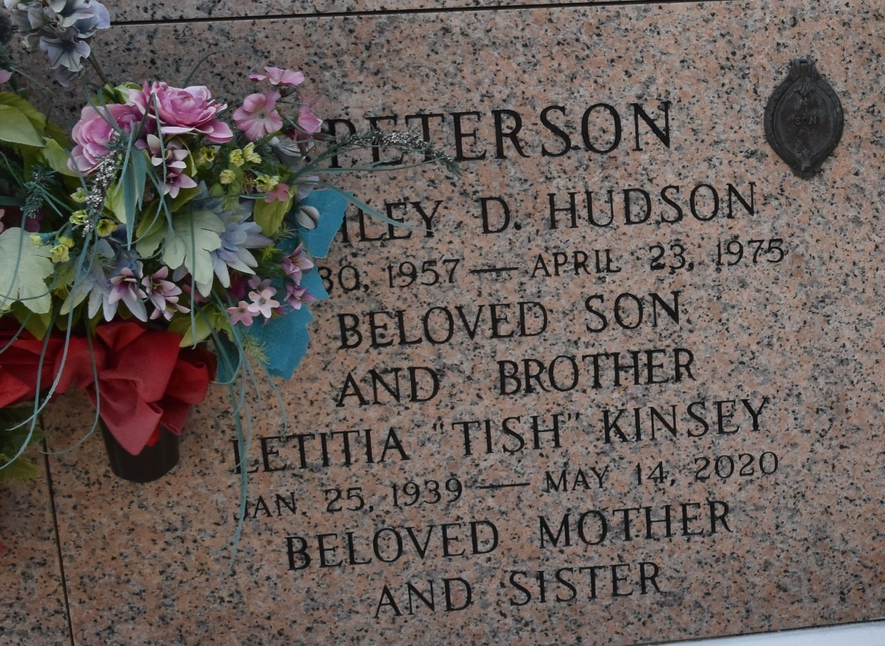

Letitia “Tish” Fruge was born on January 25, 1939 [to] Bill and Hessie Kinsey. She gained her wings on Thursday, May 14, 2020. She met Jesus and joined her son, Ashley, her parents and four siblings. She is survived by her sister, Marie and brother, Edward (Vern); children, Rhea, Lee (Elizabeth) and Vicki (Jeremy); seven grandchildren; seven great grandchildren; several nieces and nephews. She was a retired hairdresser and was adored by everyone she met. She had a kind, loving soul that shimmered and shined with her grand style and flair and she will be truly missed!!!

Church Funeral Services & Crematory, Saint Amant, Louisiana

