Richard D. Gaille Jr.
September 2, 1950 – July 1, 2018

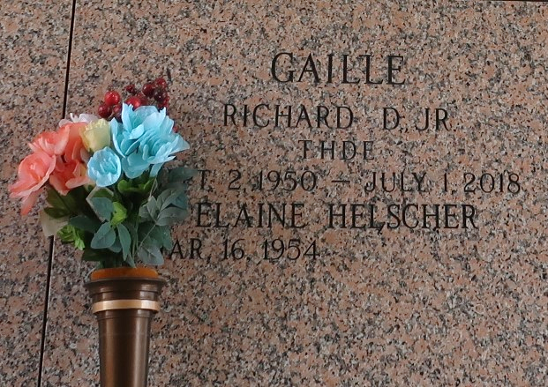

Richard D. Gaille, Jr., 67, passed away at his home surrounded by loving family on July 1, 2018. He was the son of Richard D. Gaille, Sr. and the late Lorraine Wright Gaille. He is also survived by his wife of 39 years, Elaine Helscher Gaille, his sisters Linda Anderson and Marlane Gaille, his nieces Lauren Flores and Claire Pantell, his nephews Matthew Paige and Clay Gaille.
He was a retired Athletic Director and head Football Coach at St. James High School. He had many accomplishments in the realms of golf, football coaching, and sports analysis in media at CrescentCitySports.com.
Visitation Sunday July 8th from 4 P.M. until 8 P.M. at Jacob Schoen & Son Funeral Home 3827 Canal Street. Visitation Monday July 9th from 10 A.M. until 12 Noon at Ascension of Our Lord Catholic Church in Laplace, with Mass to be Celebrated at 12 Noon. Burial in St. John Memorial Gardens Cemetery. In Lieu of flowers, donations are requested for Covenant House New Orleans. ARRANGEMENTS BY JACOB SCHOEN & SON FUNERAL HOME. Condolences may be left at www.schoenfh.com.
Downloaded from Legacy.com
August 8, 2018

