Don J. Galiano
November 6, 1942 - December 8, 2019

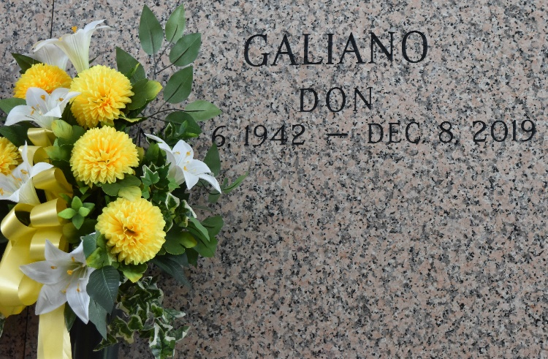

Don J. Galiano, a resident of Gramercy, passed away on Sunday, December 8, 2019 at the age of 77. He was a retired heavy equipment operator with International Union of Operating Engineers, Local No. 406 for 45 years.
He is survived by his wife of 55 years, Maria Dottolo Galiano; children Mark Galiano and wife Mie, Andrea Duhe and husband Gary, and Ryan Galiano and wife Paige; grandsons Benjamin, Dane and Justin; and siblings Edna Mae Thomassie, Rosalie Ladner and Patrick Galiano.
He is preceded in death by his parents Eusebe and Lucy Galiano, sister Dianne Bollingham and brother-in-law Felix “Brother” Dottolo.
A visitation will be held on Thursday, December 12, 2019 at Most Sacred Heart of Jesus Catholic Church in Gramercy, LA from 9:00 AM until funeral time. A Mass of Christian Burial will take place at 11:00 AM. Interment will follow in St. John Memorial Gardens in LaPlace, LA.
The family would like to thank the surgical nursing staff and Dr. Cullen Ocmond at St. James Hospital, Dr. Andrew Dalovisio and Juliette of Ochsner Cancer Center.
If you wish to remember him in a special way, consider offering Masses or monetary donations to St. Jude’s Children’s Hospital.

Rose Lynn Funeral Services, Lutcher, Louisiana

