Joseph Galland
November 20, 1947 - February 18, 2020

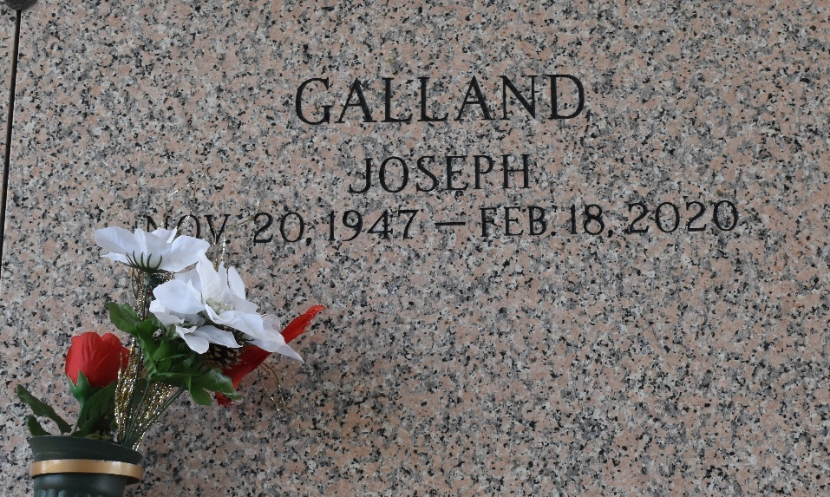

Joseph (Joe) Galland, a native of Baton Rouge, LA and resident of LaPlace, LA passed away on Tuesday, February 18, 2020. He was 72 years old. Joe was a retired piping designer of over 30 years. He is survived by: his wife of over 24 years, Lily Acosta Galland; daughter Suzanne G. Dumez (Steve); son Chad Galland; stepdaughter Tania Millet (Jeffrey); grandchildren - André, Corinne, Brandon, Chad Jr., Corey, Haley, and Marleigh; and numerous cousins.
He was preceded in death by his parents Otis Galland and Laurice Armoney Galland, and a sister Rose Galland.
Relatives and friends are invited to attend the Memorial Mass at St. Joan of Arc Catholic Church, 529 W. 5th Street, LaPlace on Saturday, February 22, 2020 at 11:00 a.m. Visitation at the church will be held from 9:30 a.m. until 11:00 a.m. Interment in St. John Memorial Gardens Cemetery. In lieu of flowers, memorial contributions may be made to St. John Ministry of Care, 532 W. 5th Street, LaPlace, LA 70068.
Millet-Guidry Funeral Home, LaPlace, Louisiana
February 20, 2020

