Nicholas Joseph Gamble

April 3, 1979 – September 20, 2007

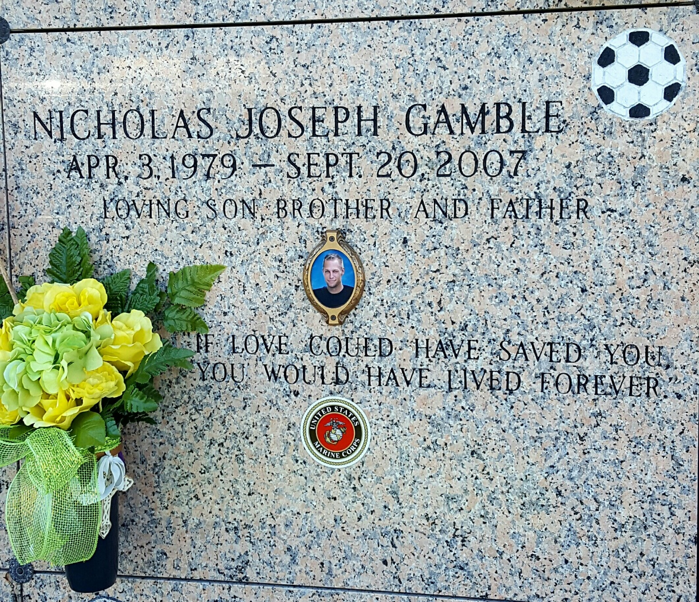

Photo by mbc

Nicholas (Nick) Gamble, on Thursday, September 20, 2007, at 9:30 p.m. Beloved father of Colson Gamble. Son of Gary and Vickie Gamble. Brother of Heather Gamble. He was a member of The United States Marine Corps. Age 28. A former resident of Thibodaux, LA. and a resident of Laplace for the past 25 years.  
  
Relatives and friends are invited to attend services. Visitation at Millet-Guidry Funeral Home, 2806 W. Airline Hwy., Laplace, on Tuesday, September 25, 2007 from 10 a.m. until 12 noon. Followed by religious services at the funeral home chapel at 12 noon.

**Times-Picayune, The (New Orleans, LA) - Sunday, September 23, 2007**

**Contributed by Jane Edson**