Alvaro Gaspar Garcia

August 23, 1933 – May 31, 2006

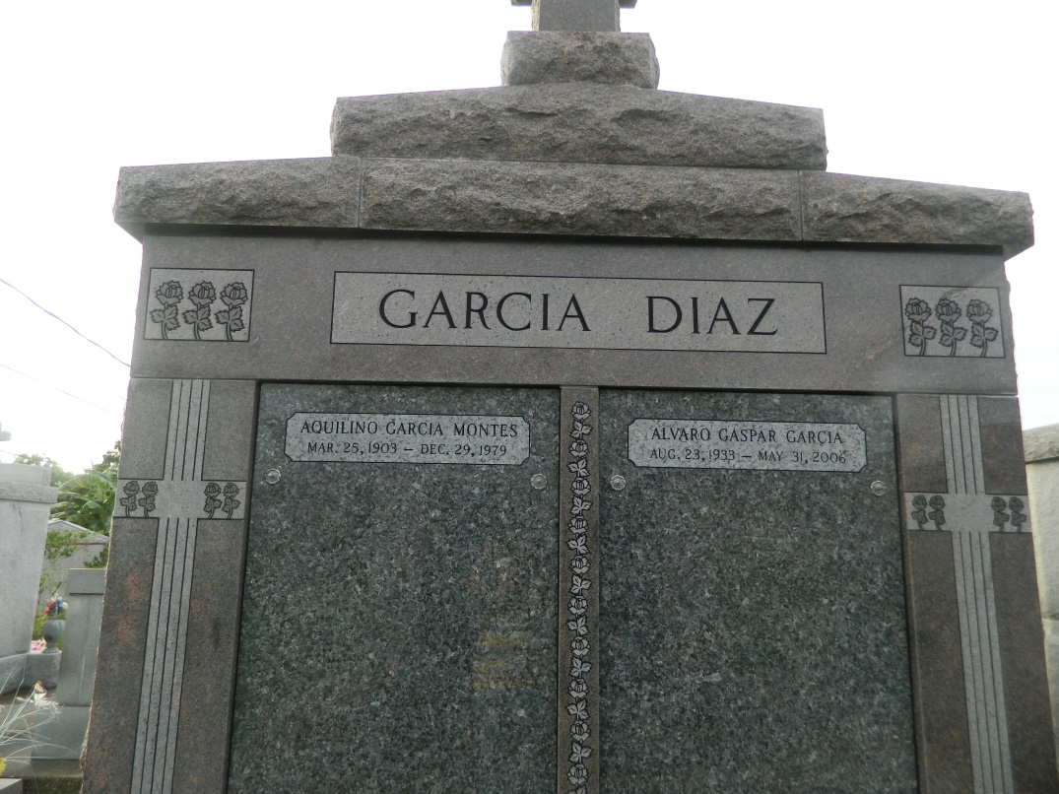

LAPLACE - Alvaro Gaspar Garcia, 72, a native of Havana, Cuba and a resident of LaPlace, died May 31. He was the husband of Maria Elena Garcia.  
  
He is survived by his children Alvaro Garcia, Mel Clement, Elena Garcia and Maria Victoria Coy.  
  
He is also survived by his mother Celerina Garcia, sister Maria Lusia Tabe, sister-in-law Dions Garcia and grandchildren Malena, Christina, Diego, Alex and August.  
  
He was preceded in death by his father Aquilino Garcia and brother Aquilino Garcia Jr.  
  
Services were held June 2 at St. Joan of Arc Catholic Church, LaPlace, with interment in St John Memorial Gardens Cemetery, LaPlace.

L'Observateur (La Place, LA) - Monday, June 5, 2006

Contributed by Jane Edson